NODE JS

- What is Node.JS?
- • Node.js® is a JavaScript runtime built on Chrome's V8 JavaScript engine.
- • Node.js is designed to build scalable network applications.
- • Node.js can be downloaded from the official Node.js website: https://nodejs.org.
- • Node.js is free and an open-source server environment.
- • Node.js allows us to run JavaScript on the server.
- • Node.js can run on multiple OS.

- Why use Node.JS?
- • You can use JavaScript in the entire stack.
- • Many famous companies use node.js as their backend.
- • Node.js comes with a lot of useful built in modules.
- • Node.js is fast.

- Node.JS REPL (READ, EVAL, PRINT, LOOP)

- Repl Basic
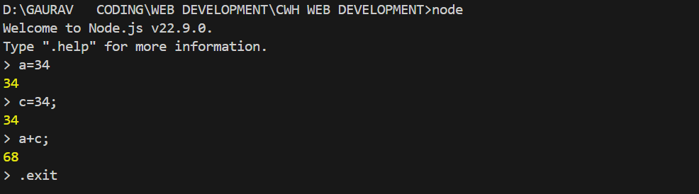

- In Repl _ means Last Variable
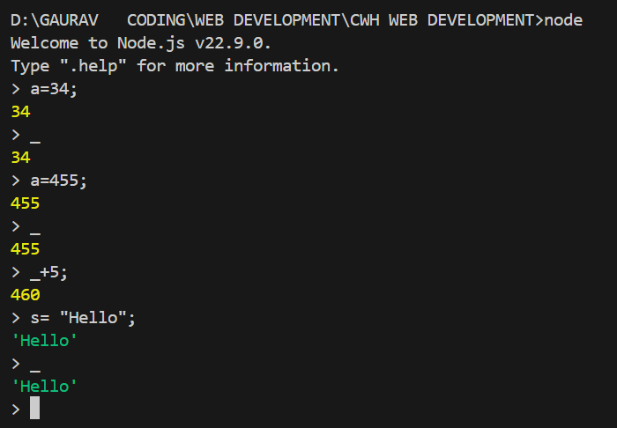
69)
npm
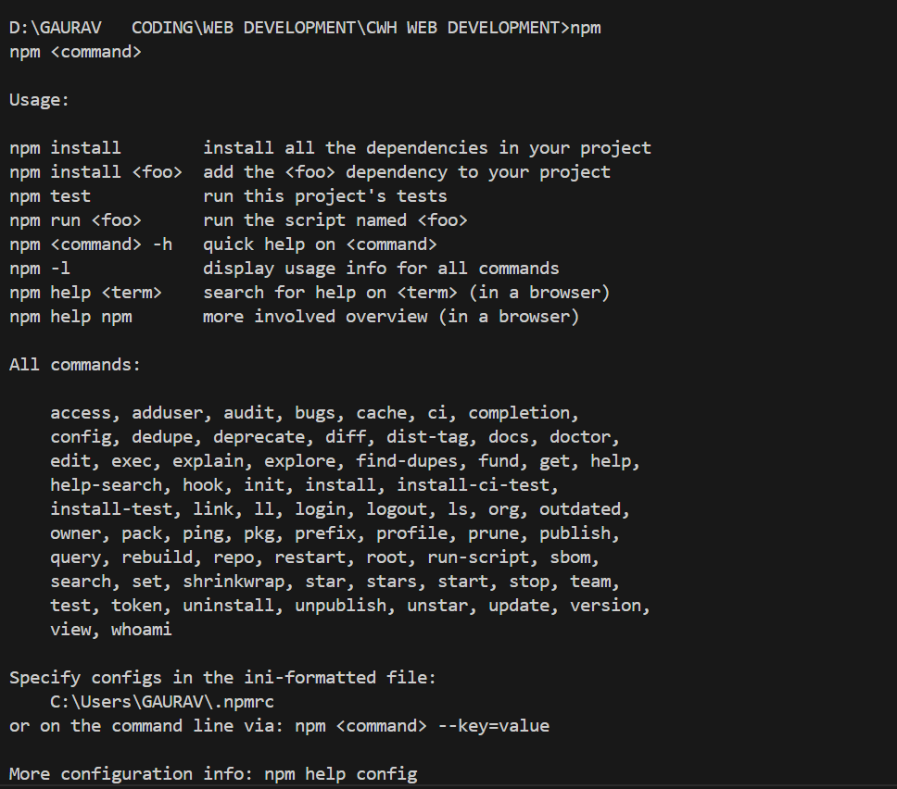
npm init
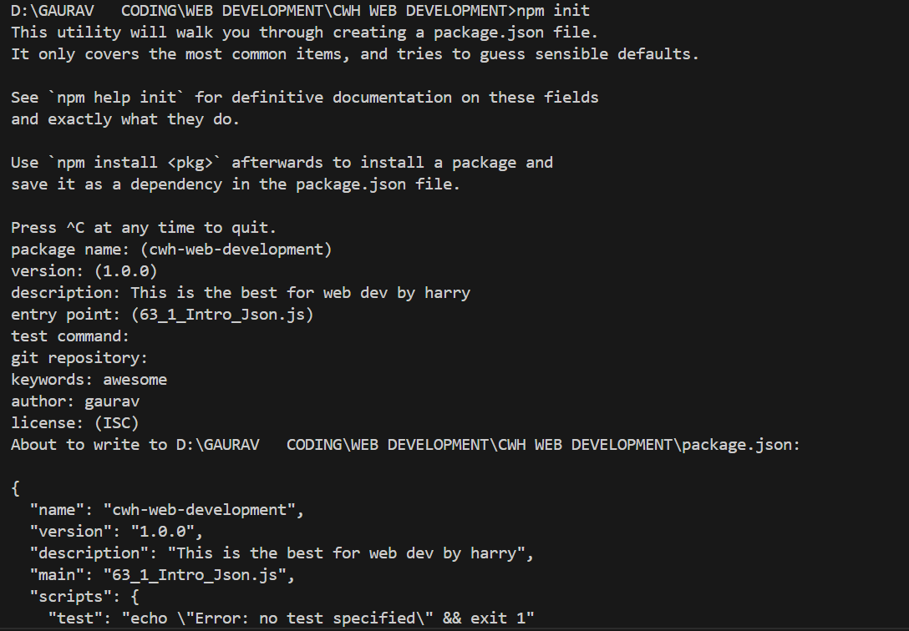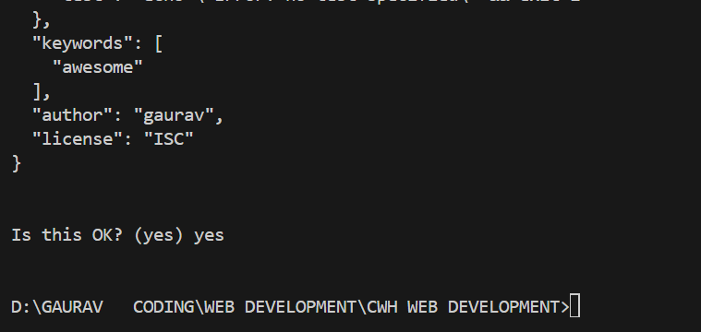
It created
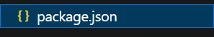
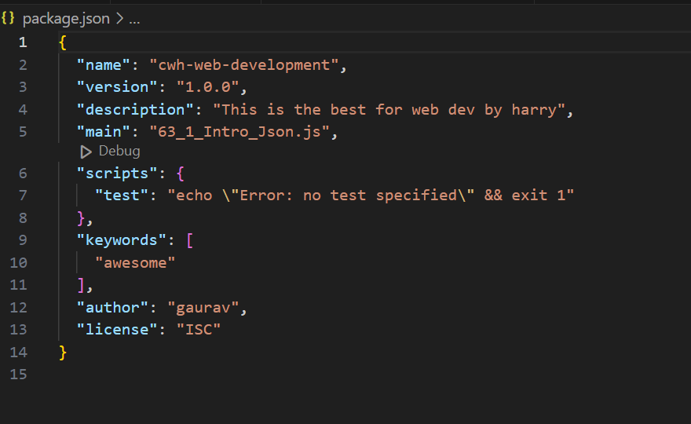
npm install …..
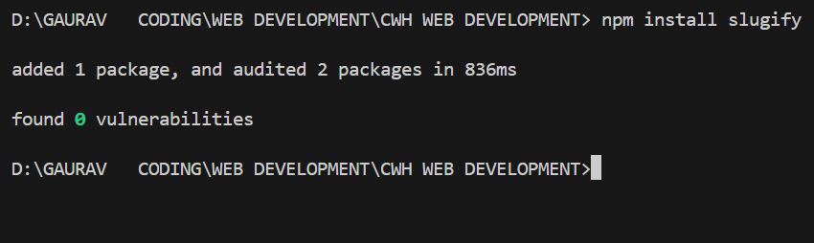
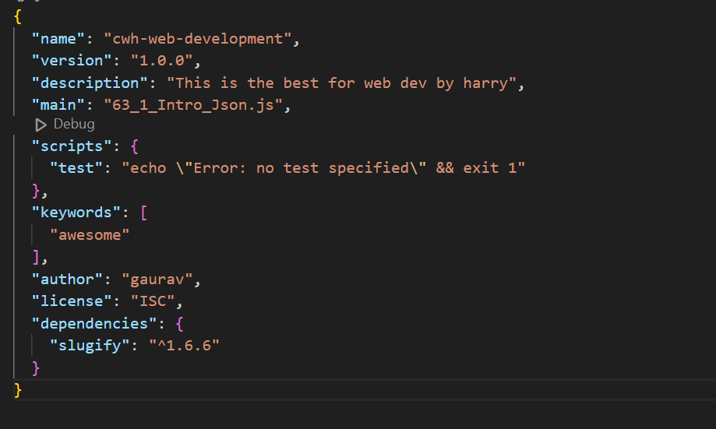
Npm install ….
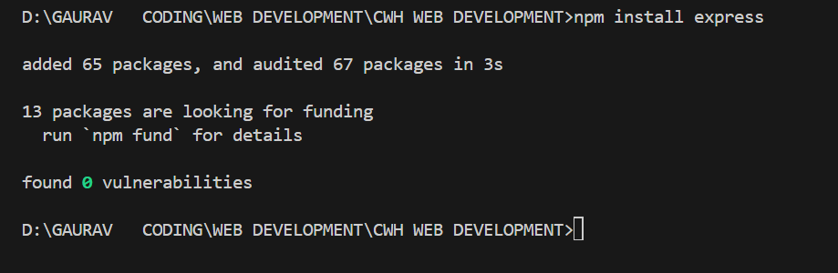
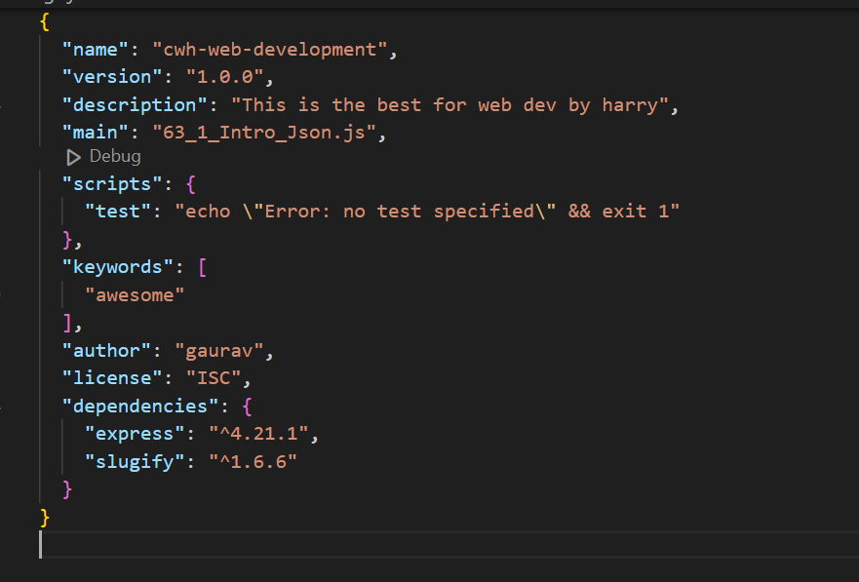
Npm unistall ……..
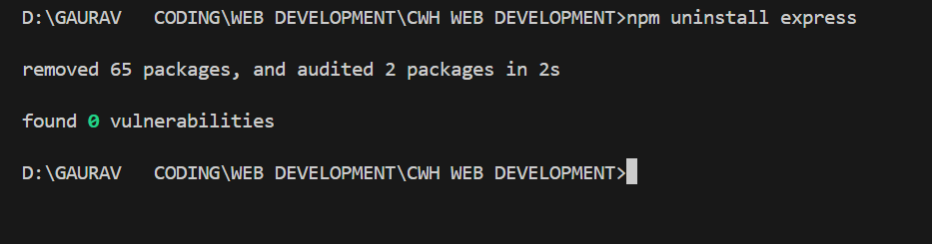
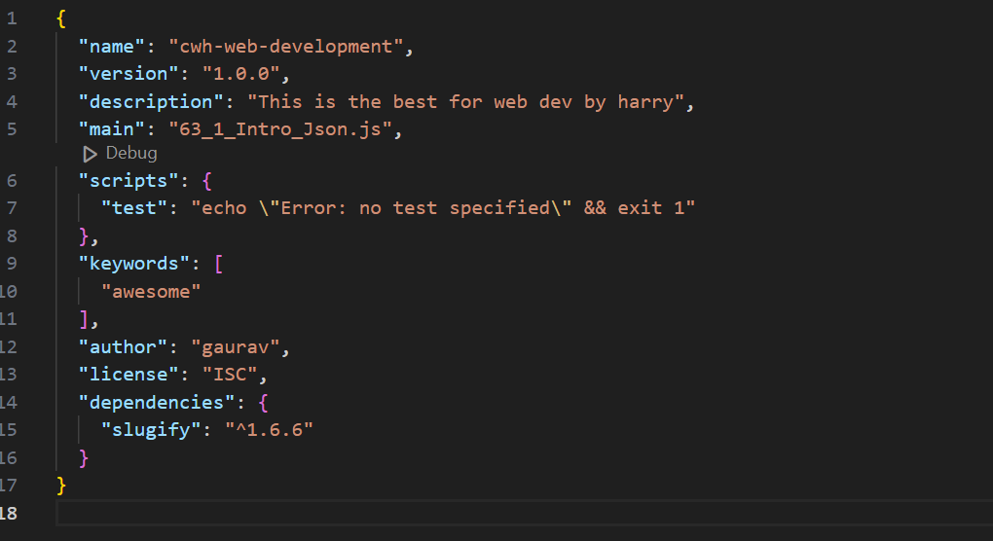
Npm install ……@version
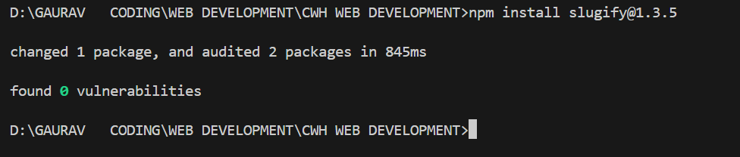
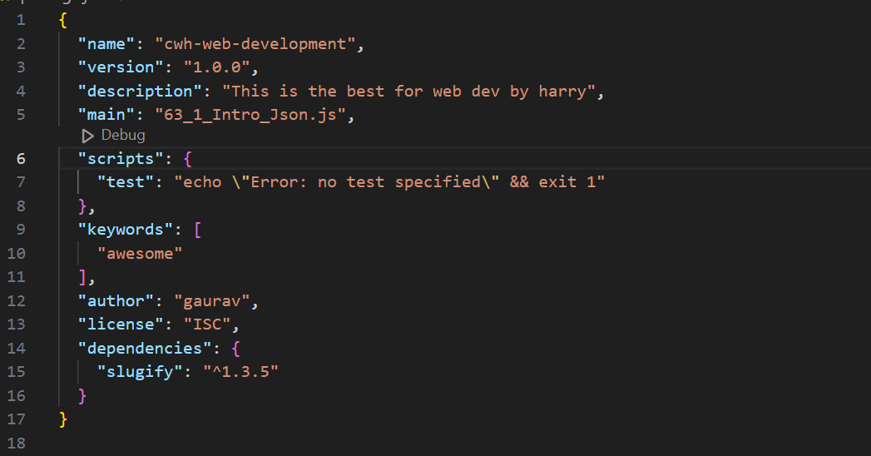

Install nodemon
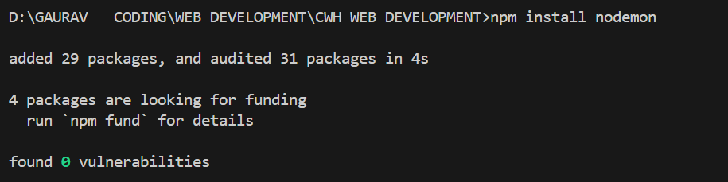
Nodemon reduces the pain of opening and closing the server (As in 66,67) it updates automatically
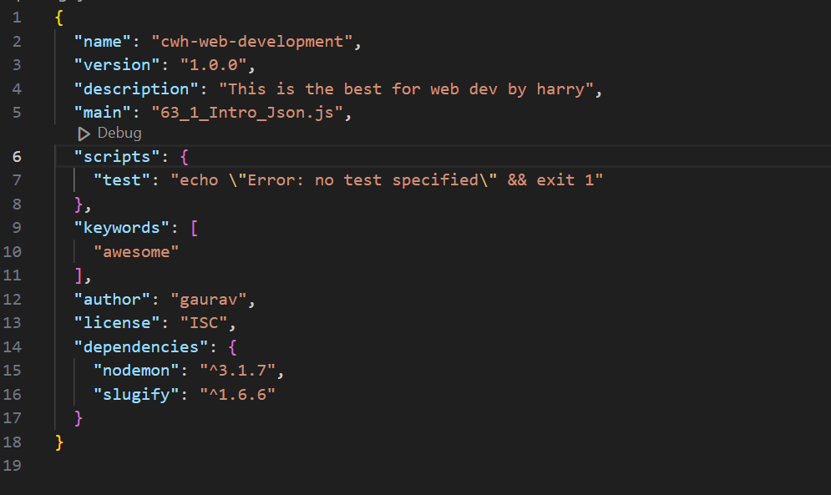

NODEMON on 69_1_NPM
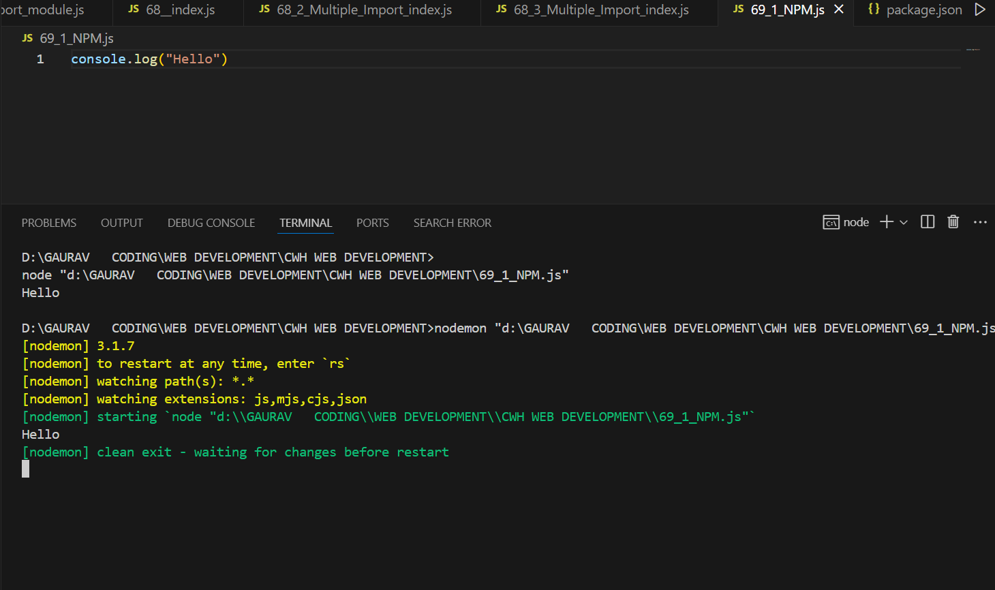
After updating 69_1_NPM
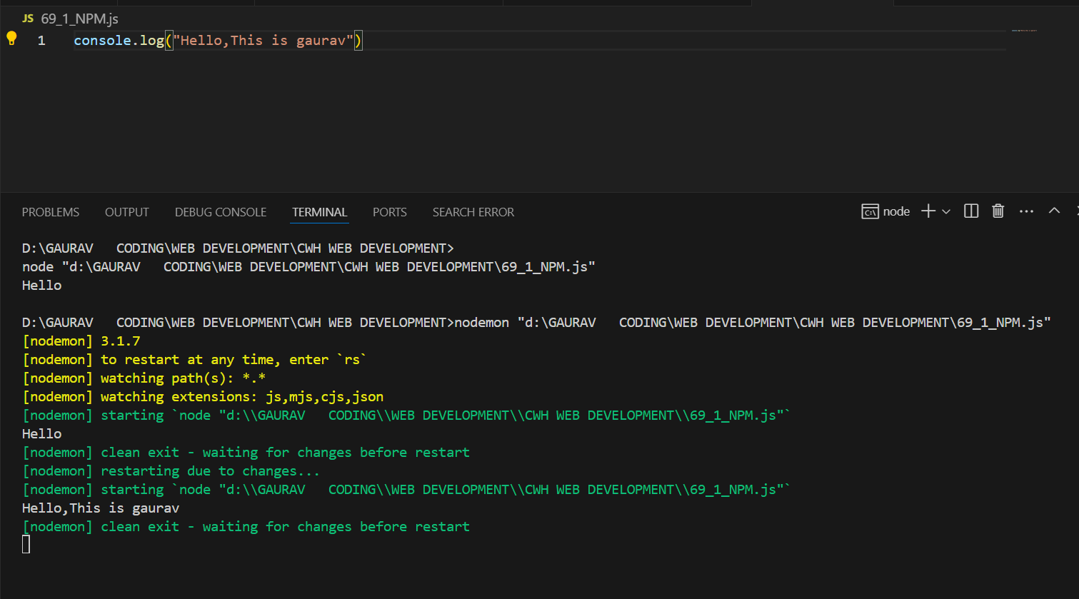

Npm install Browserify
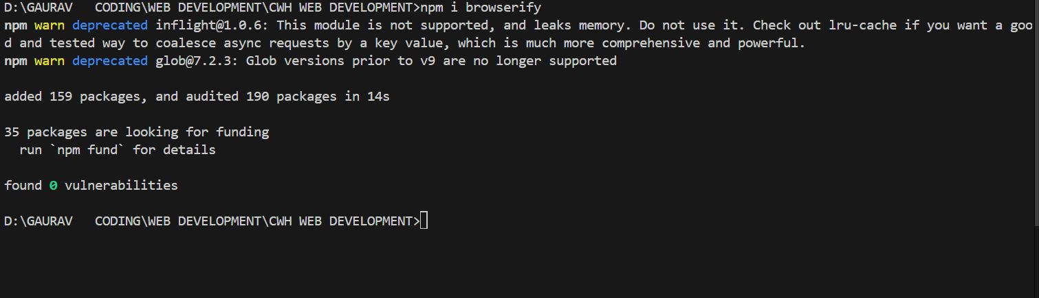
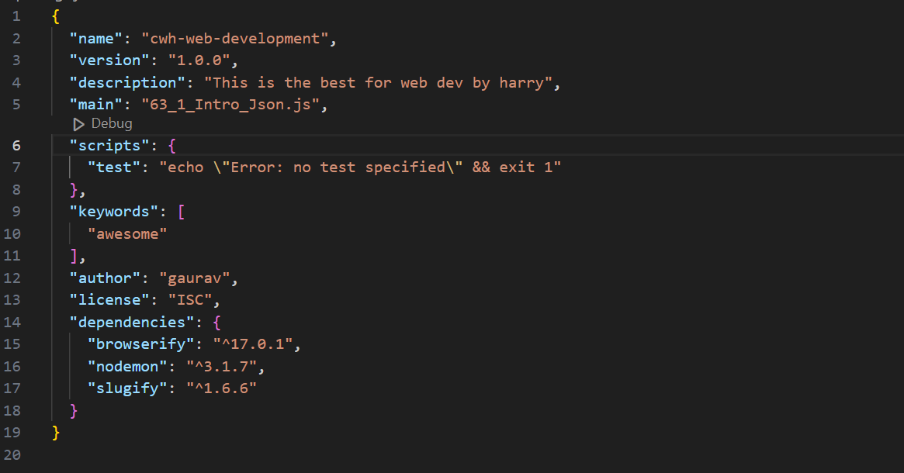
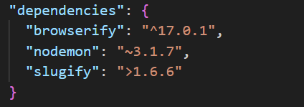
^, means strictly this version is installed
It means that npm will install the latest minor or patch version that is compatible with the specified major version.
>, means version greater than this will be installed if u write “npm i ” in the terminal
It means that npm will install any version greater than the specified one.
~,means that npm will install the latest patch version that is compatible with the specified minor version.
Npm view, used to check version of dependencies
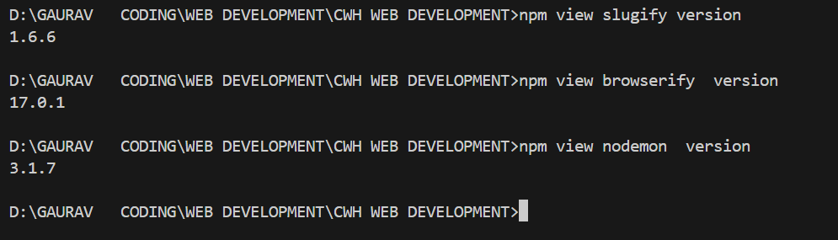
Express.js and Postman are often used together for building and testing RESTful APIs in web development.

Express.js:
- Express.js is a minimal and flexible Node.js web application framework that provides a robust set of features to develop web and mobile applications.
- It simplifies the process of building APIs and handling HTTP requests like GET, POST, PUT, and DELETE.

Key Features of Express.js:
1. Routing: Allows defining routes for various HTTP methods and URLs.
2. Middleware: Provides a mechanism to execute code during the request-response cycle.
3. Error Handling: Offers built-in error handling capabilities.
4. Scalability: Great for building scalable web applications.
5. Templates: Supports view engines for rendering dynamic HTML.

Sample Code using Express.js:
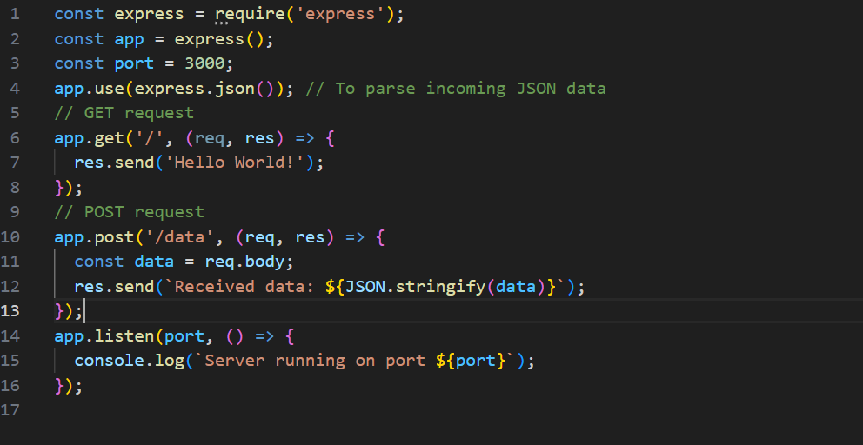
Postman: (JSONPlaceholder - Free Fake REST API)
- Postman is a popular API client that makes it easy for developers to create, test, and document APIs.
- It provides a graphical interface to send HTTP requests to your API and view the responses, making it a great tool for debugging and testing APIs built with Express or any other framework.

Key Features of Postman:
1. Send HTTP Requests: You can send GET, POST, PUT, DELETE, and other requests.
2. Environment Variables: Manage different environments for testing (e.g., local, production).
3. Collections: Organize and save your API requests into collections.
4. Automated Testing: Write tests for your API and run them automatically.
5. API Documentation: Generate API documentation easily.

Using Postman with Express.js:
1. Install and Run Express Server: Set up your Express server (as shown above).
2. Open Postman: Enter the API endpoint URL (e.g., `http://localhost:3000/data` for a POST request).
3. Send Requests: Select the HTTP method (e.g., GET, POST), add headers (e.g., Content-Type: application/json), and include body data for POST/PUT requests.
4. View Responses: Postman will display the server's response, helping you verify your API behavior.

Together, Express.js and Postman allow developers to efficiently build and test web APIs.
In Postman, you can use GET and POST requests to interact with APIs.
1. GET Request in Postman:
A GET request is used to retrieve data from the server. When you send a GET request, you're asking the server to return some data based on the endpoint and query parameters.
2. POST Request in Postman:
A POST request is used to send data to the server to create a new resource. It usually includes a request body (like form data or JSON) to send along with the request.
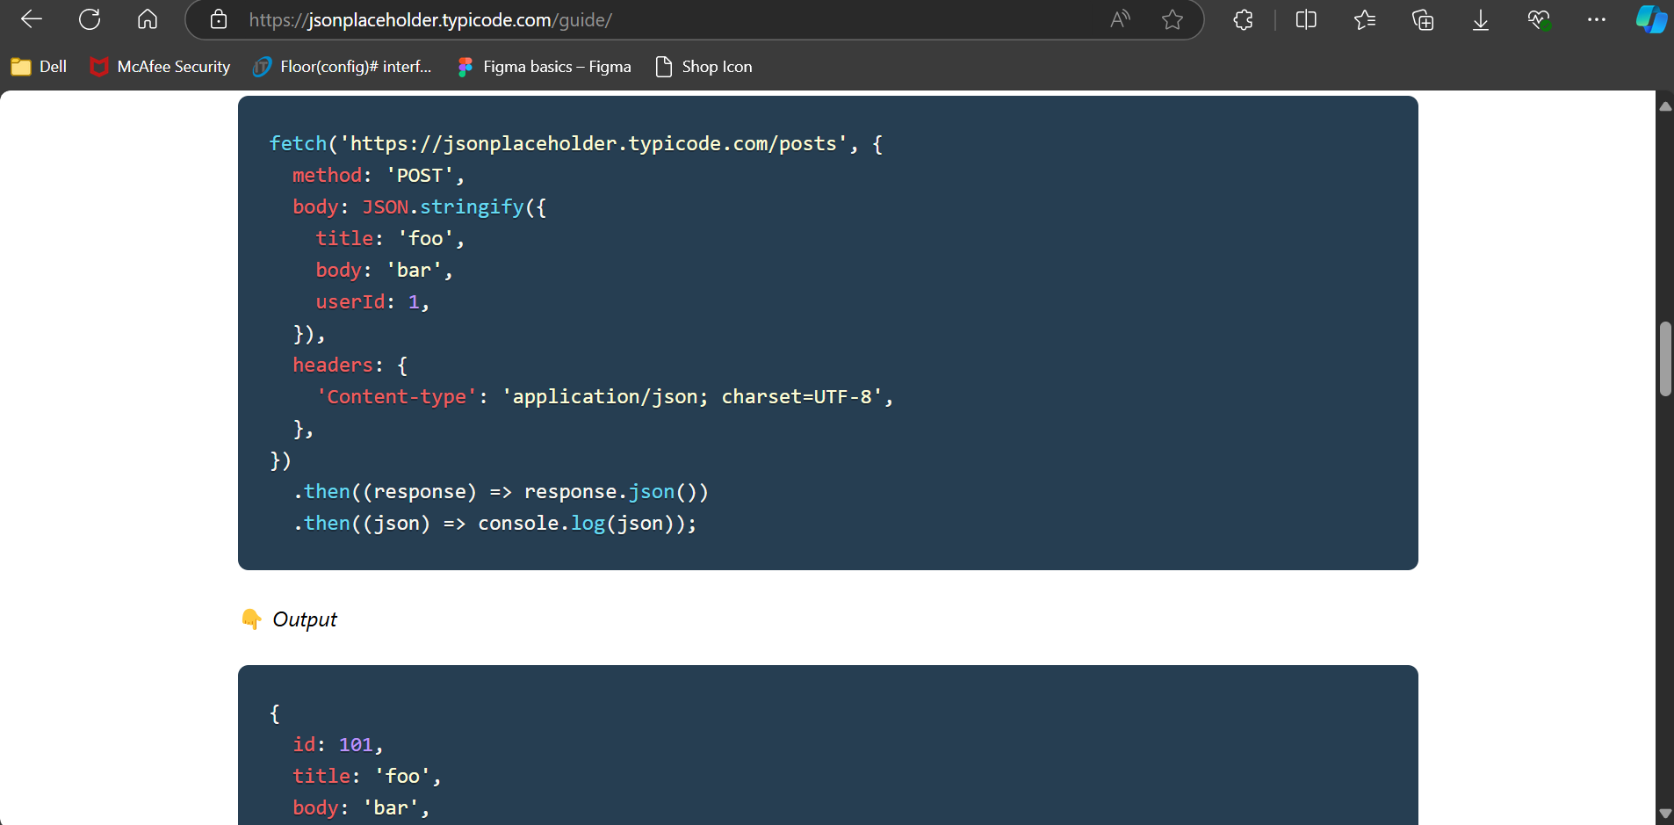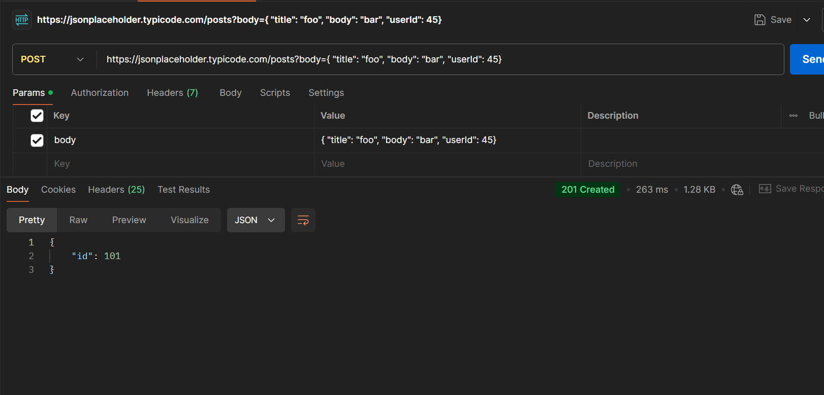

Express JS :
Setup:-
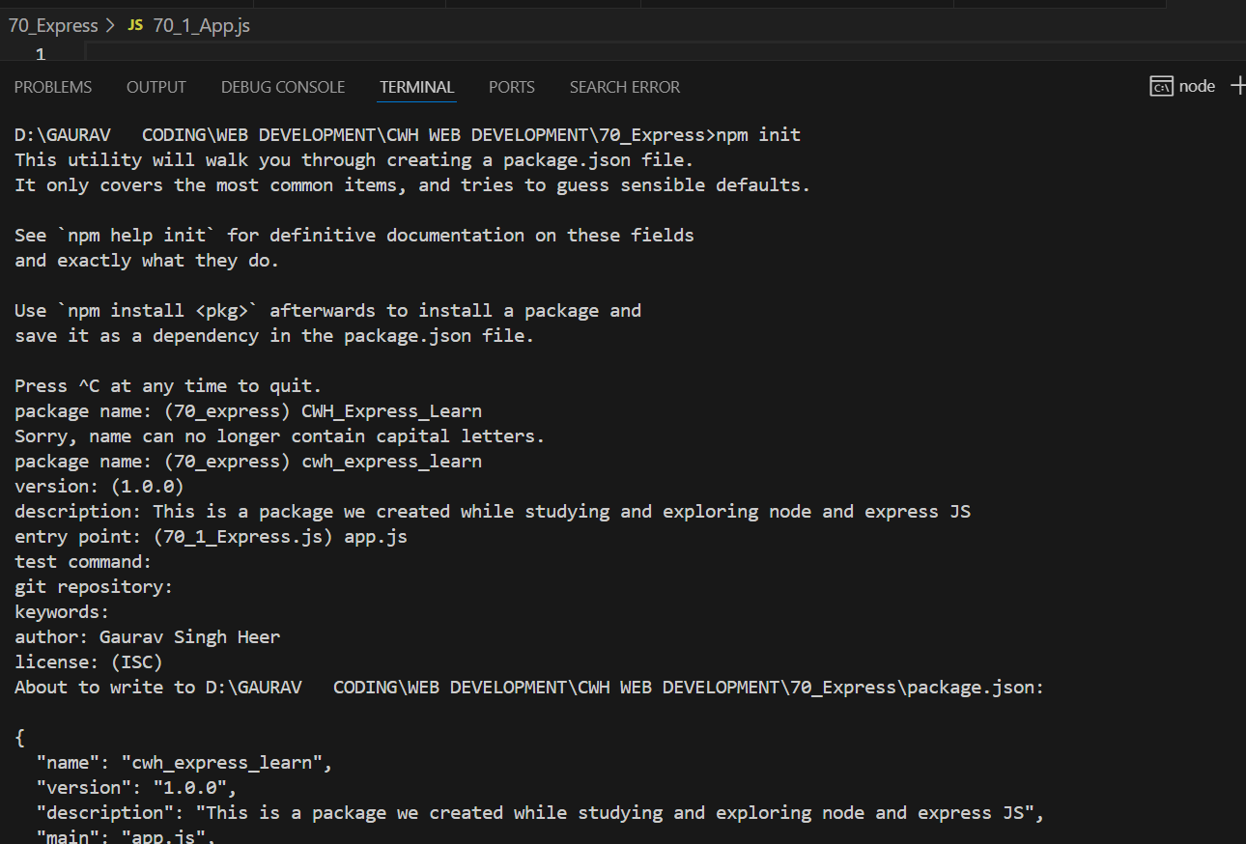
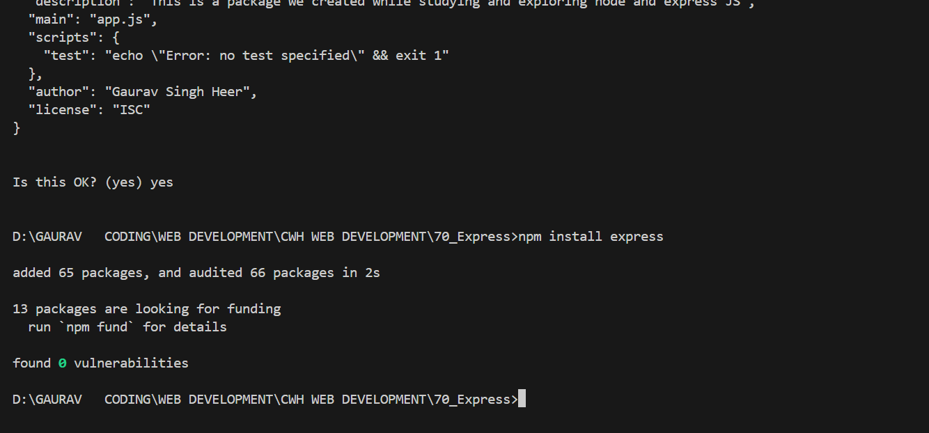

First Express App
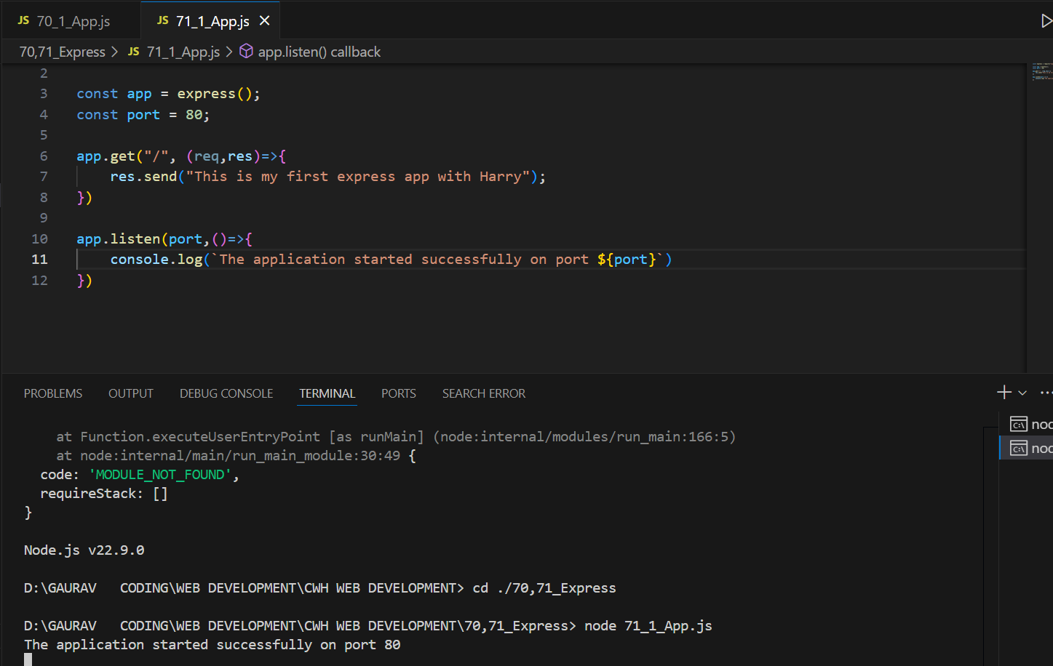
Now go to postman
And Do, This
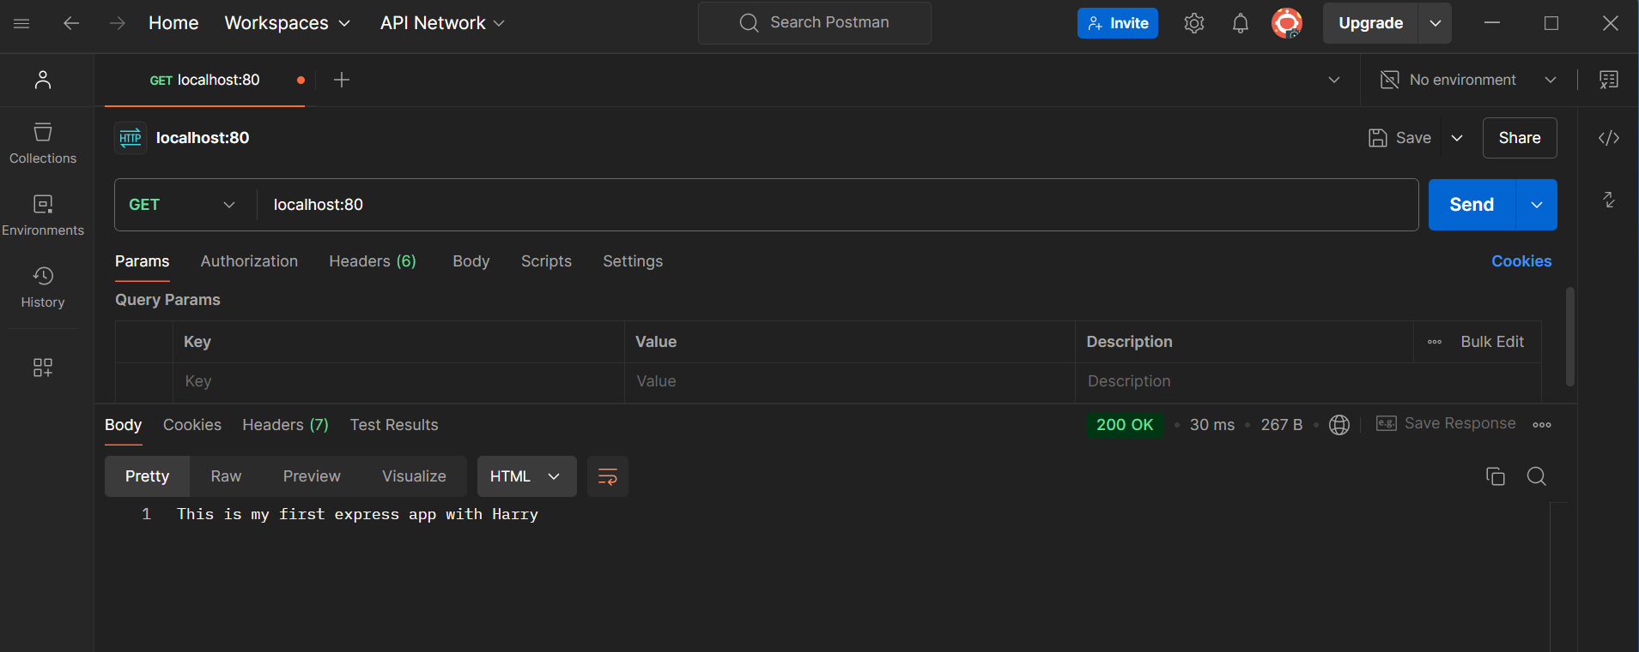
OR This,
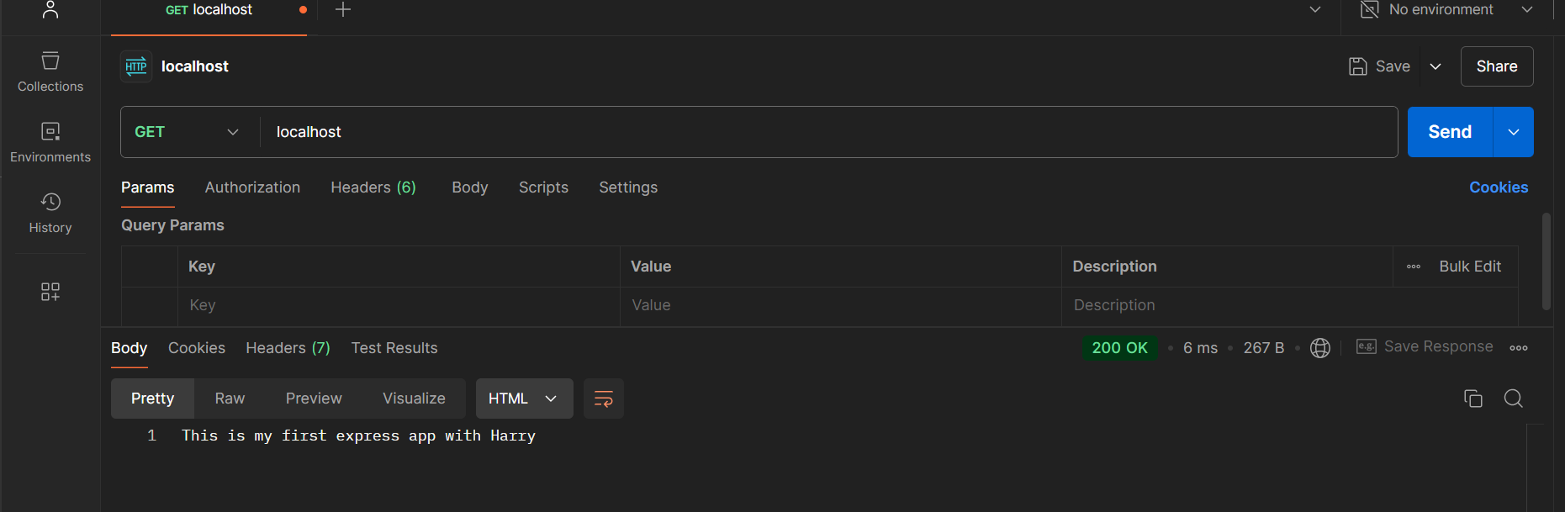

At web
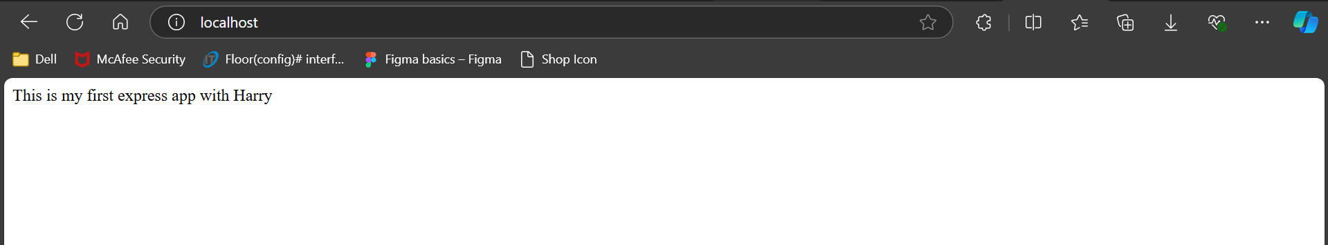
Postman will be useful when we post a request
App.get
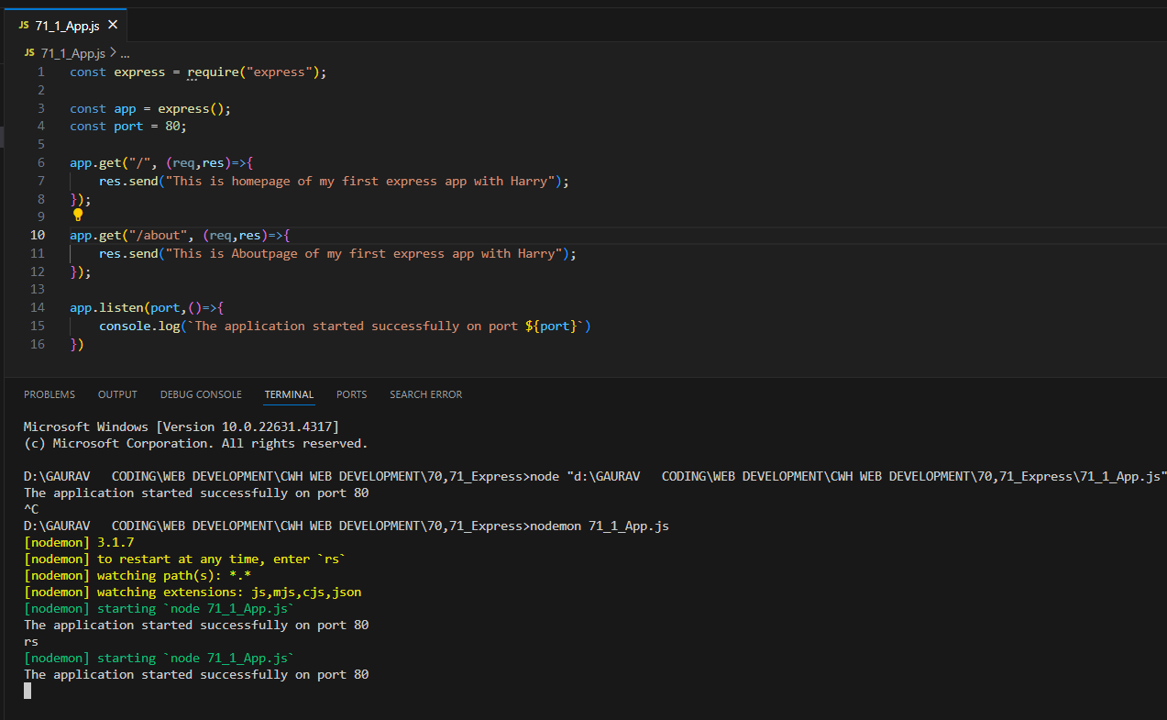
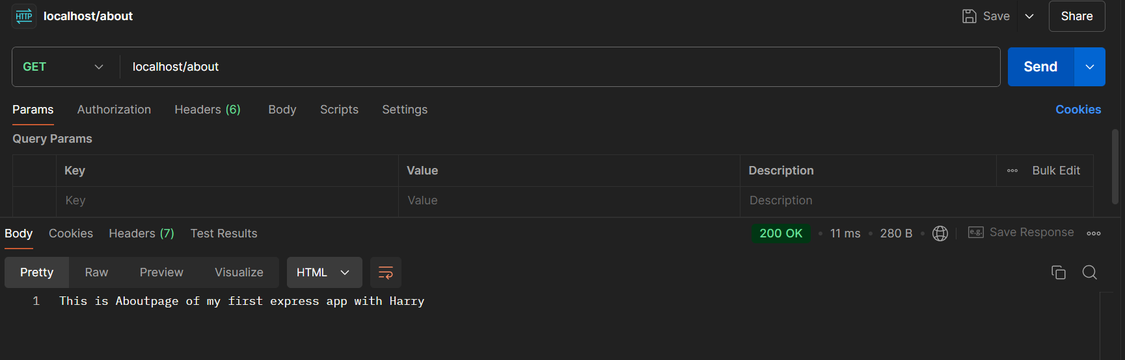
App.post
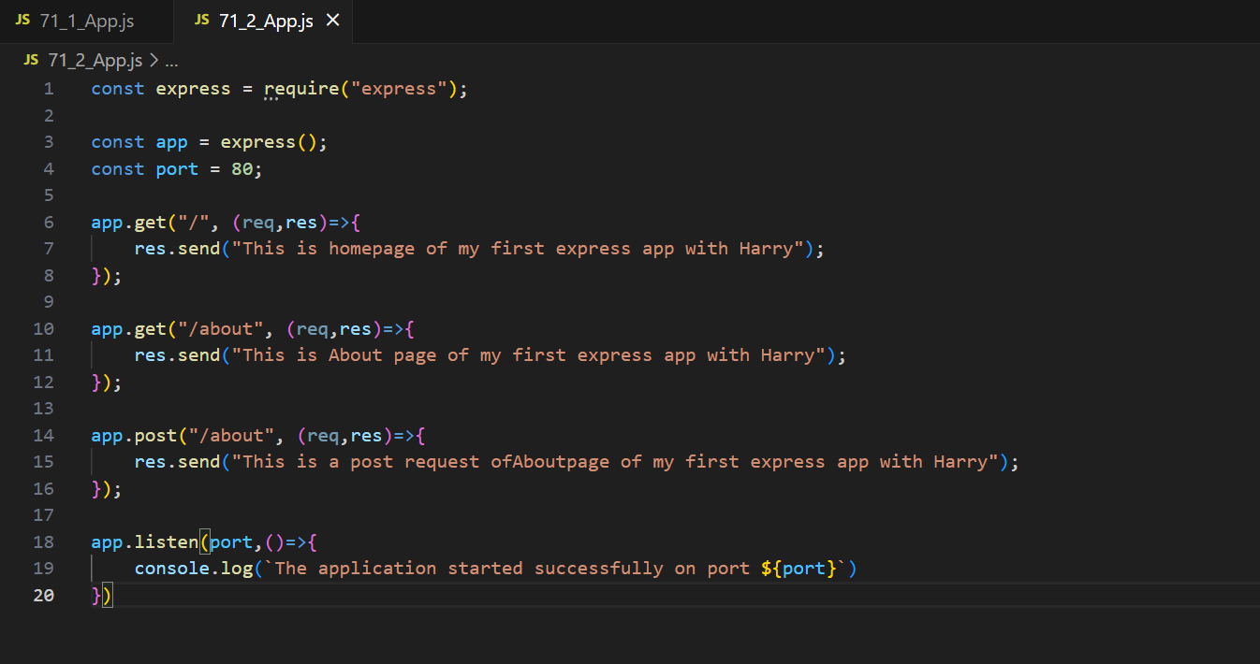
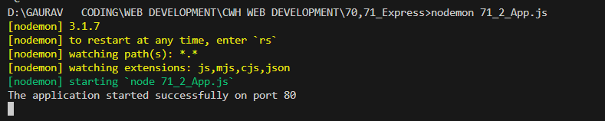
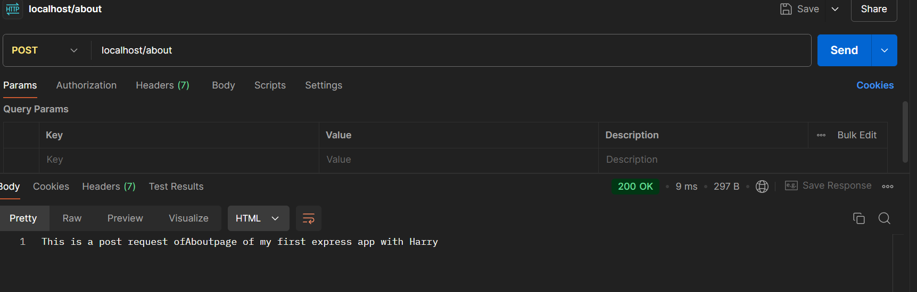
Send status-code along 200 (OK)
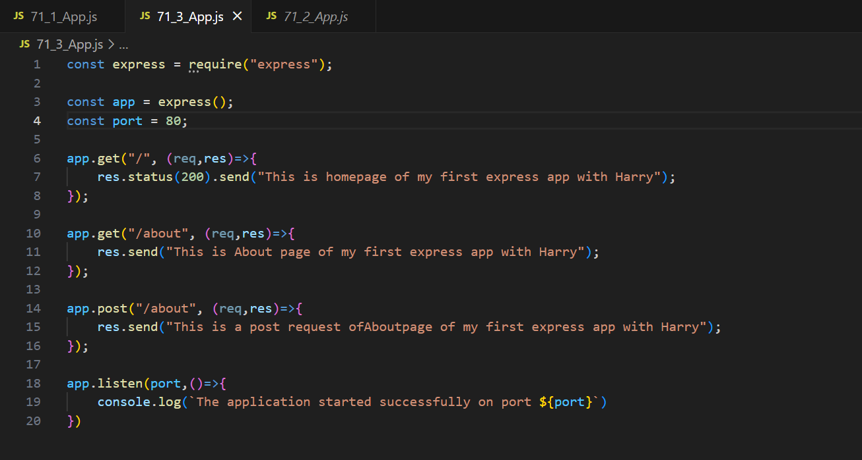
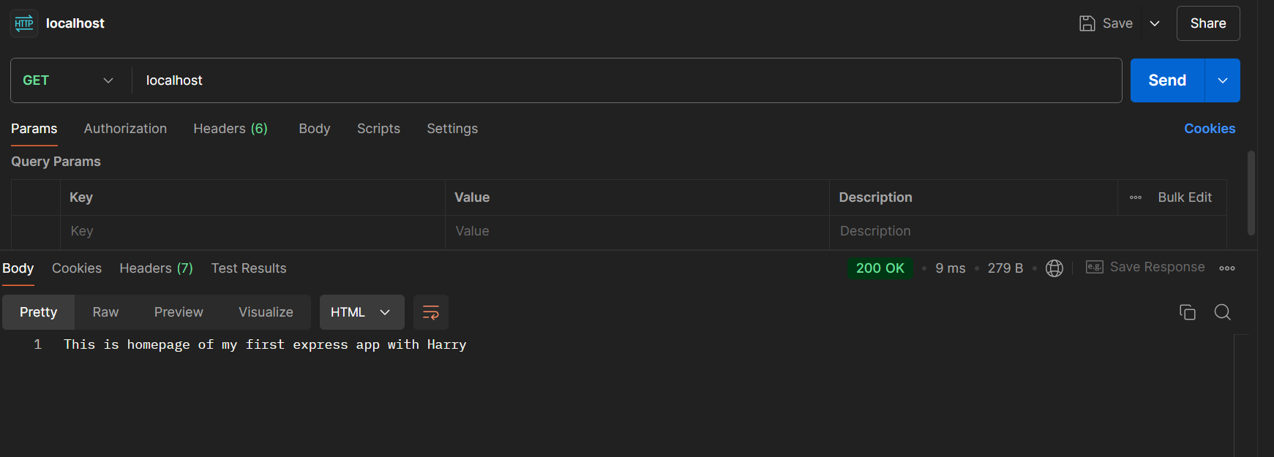
Send status-code along 404 (Not Found)
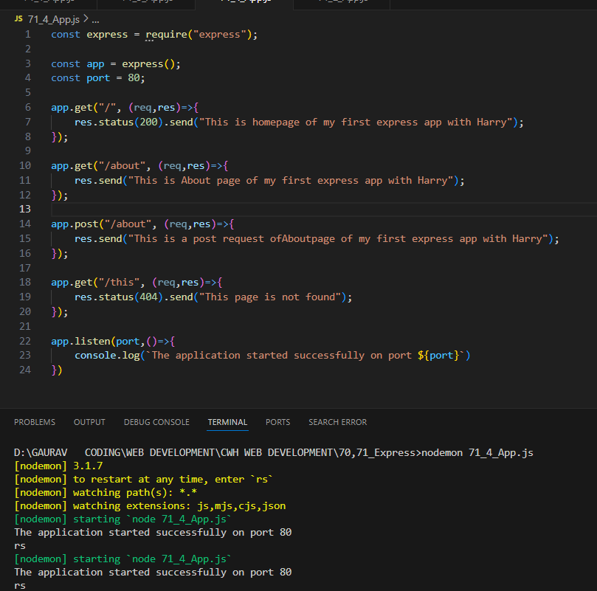
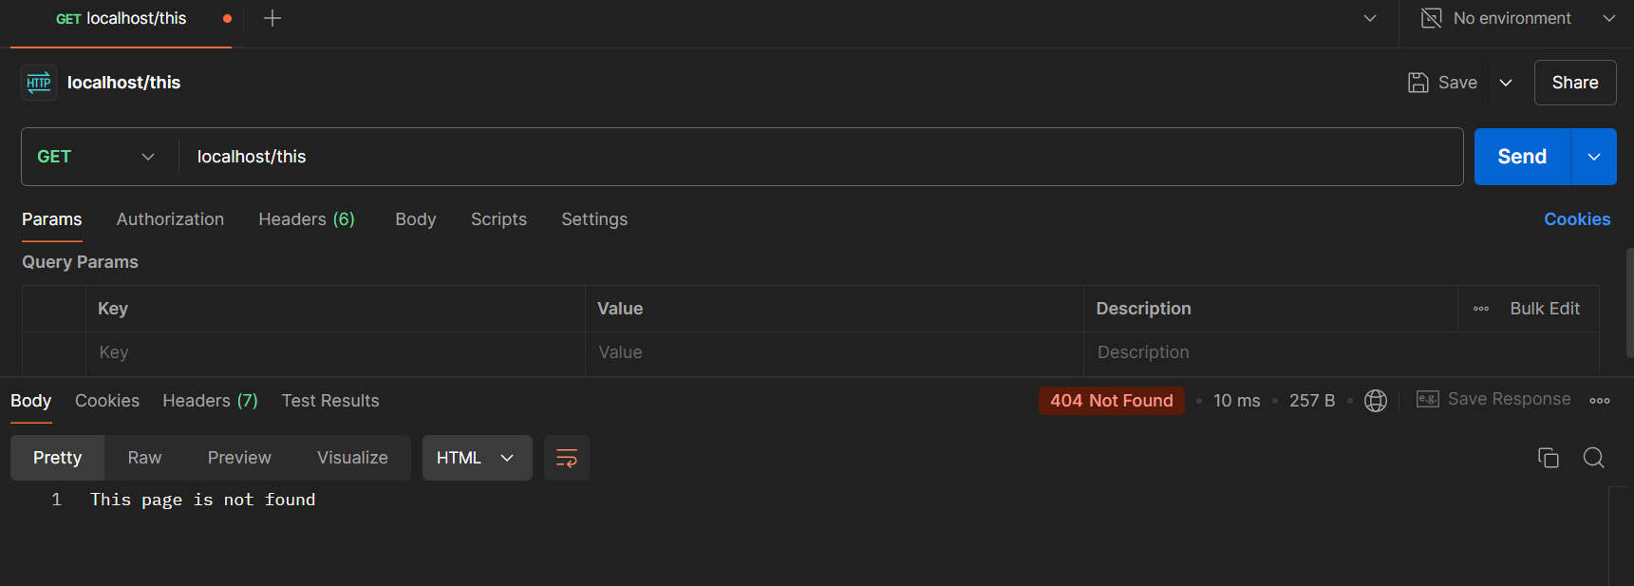
Static Files Express JS
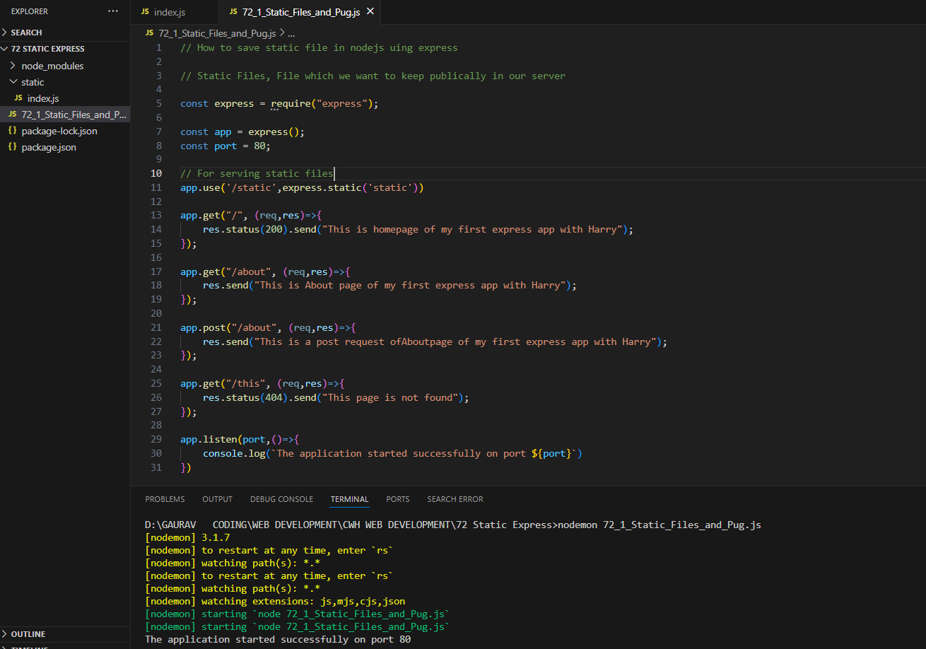
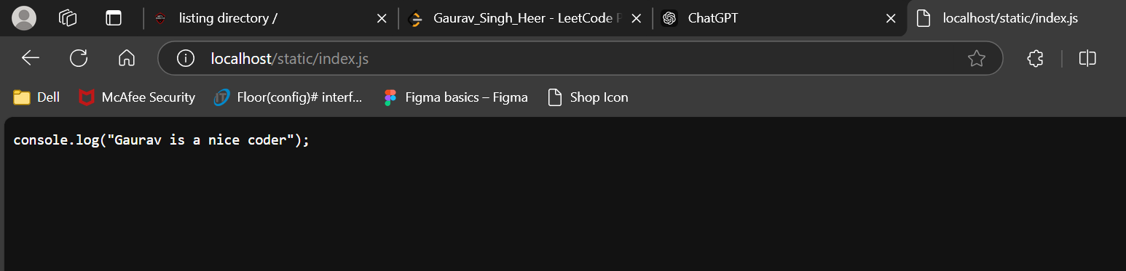
Npm install pug
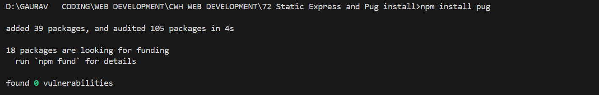
Using template engines with Express

Pug Installation
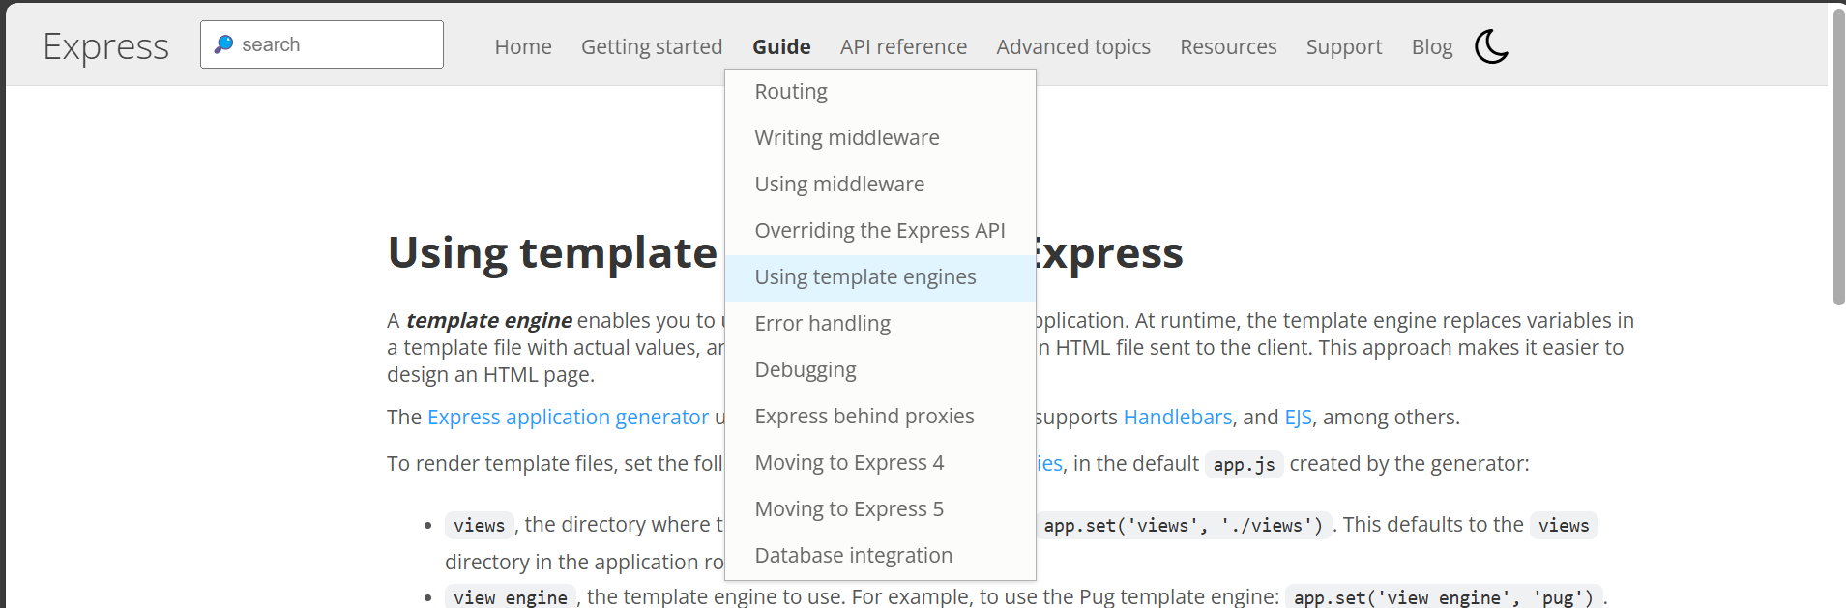
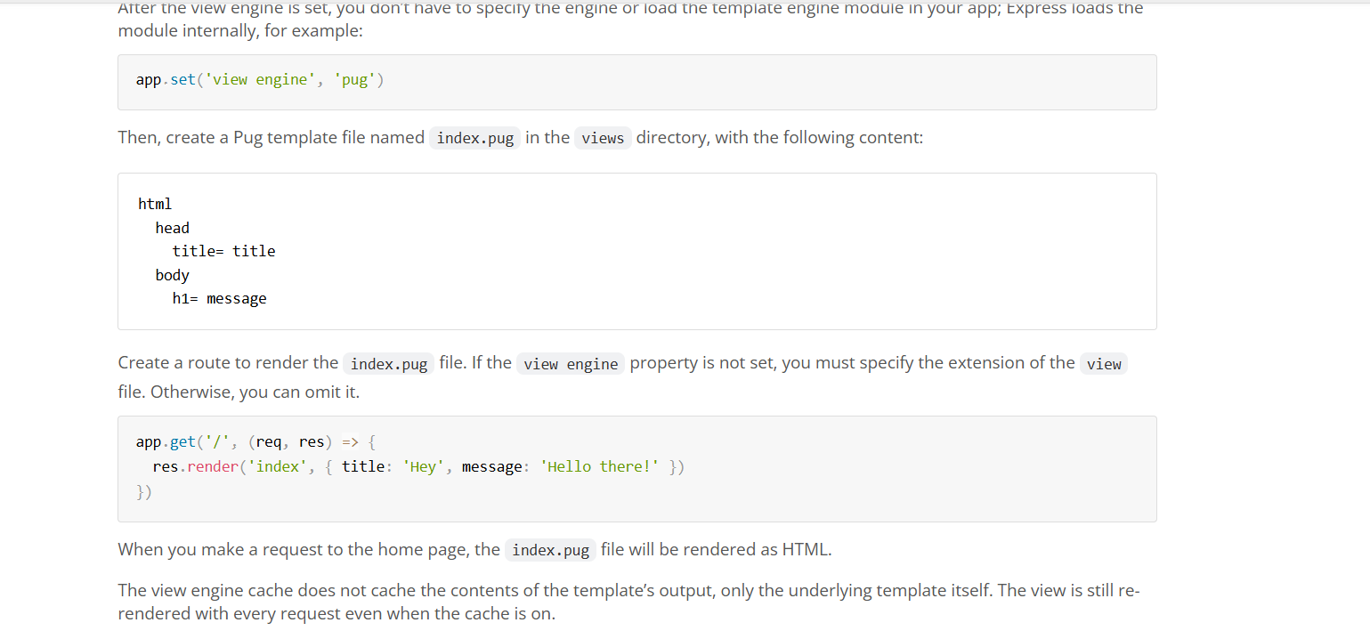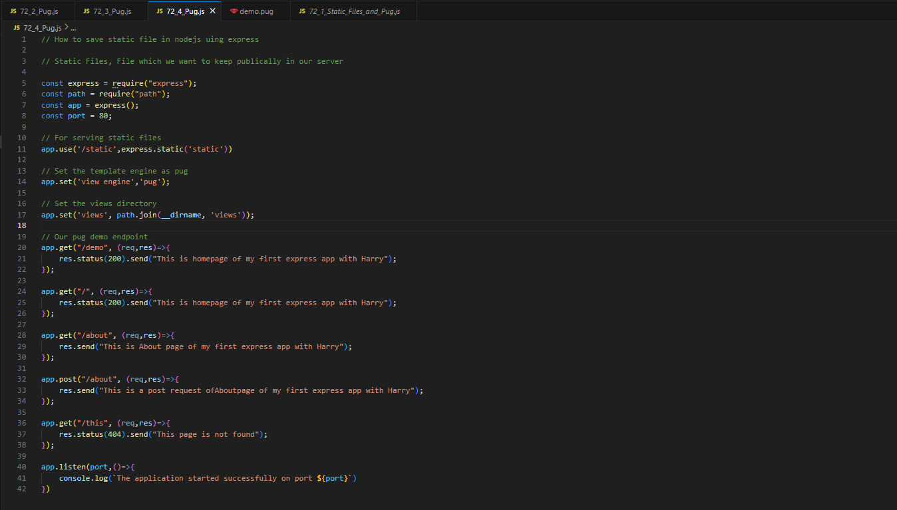
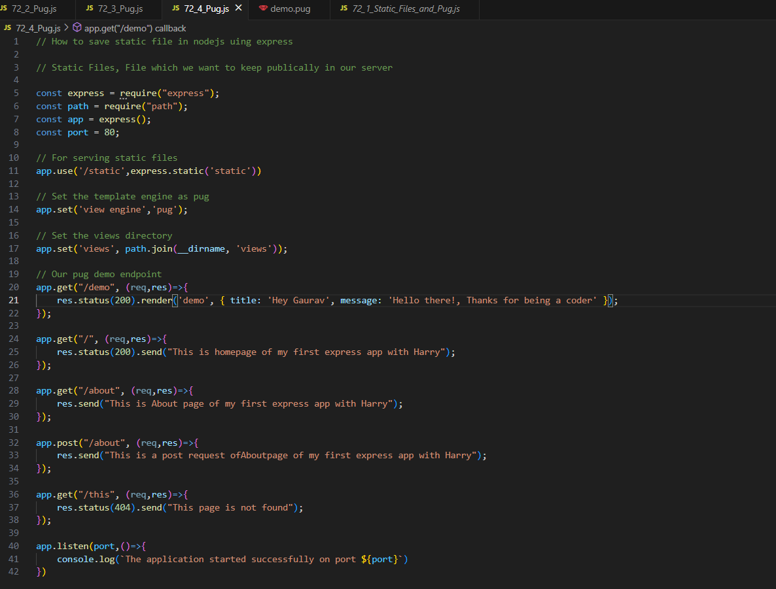
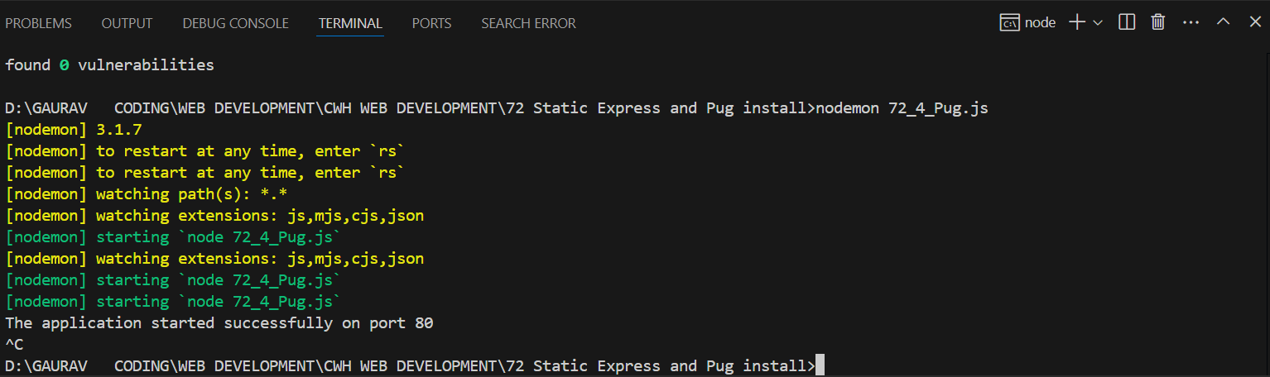
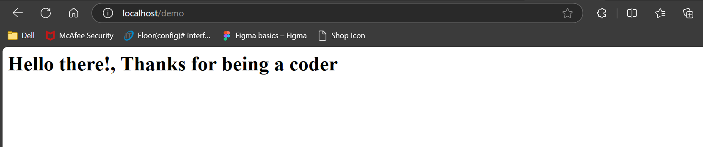
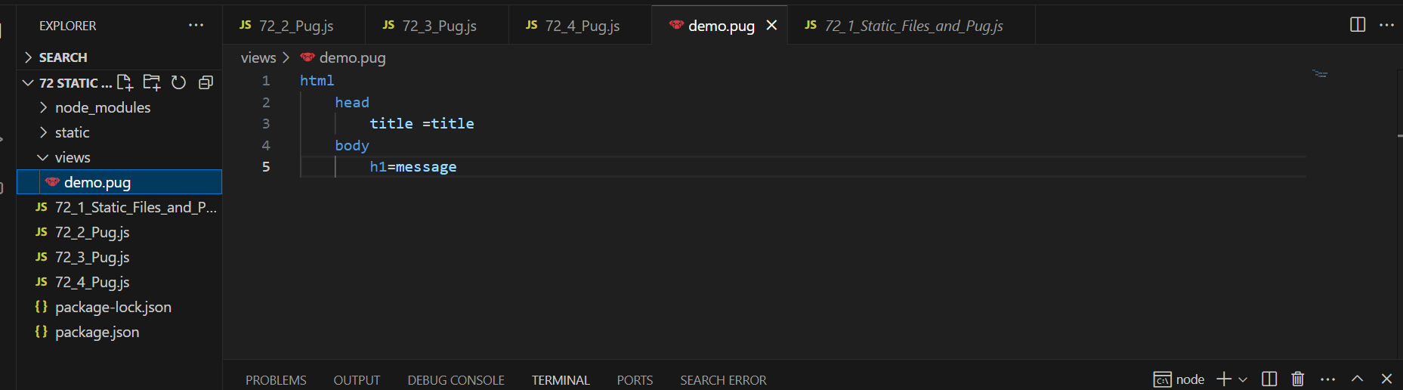

View Page Source
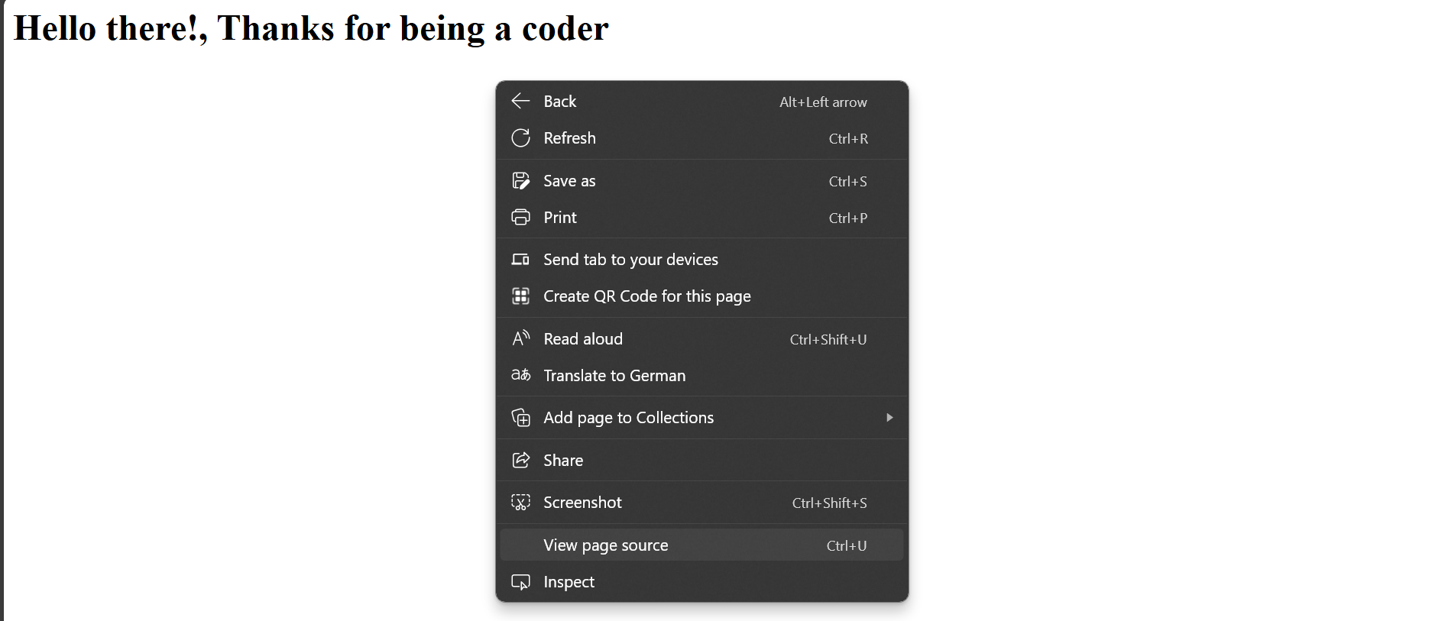
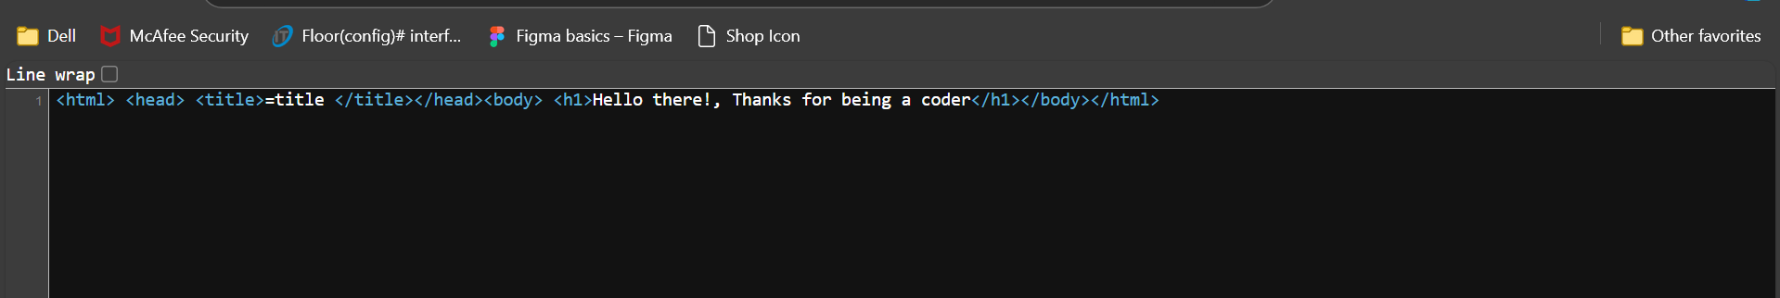
Added more file to Static
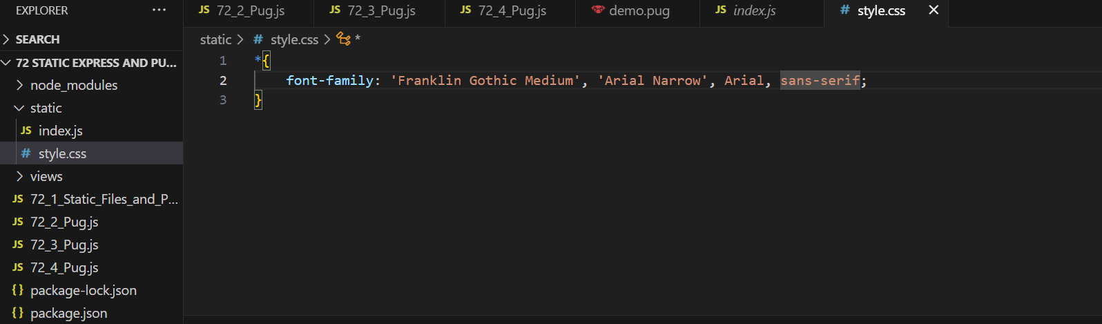
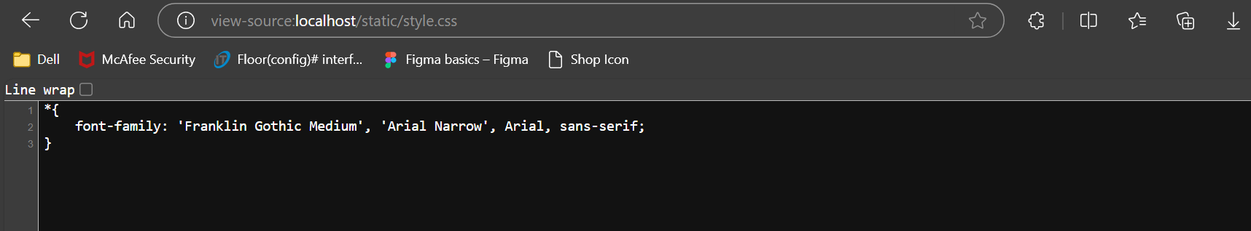
73)Using Raw Html in Pug (Getting Started - Pug,Unbuffered Code - Pug)
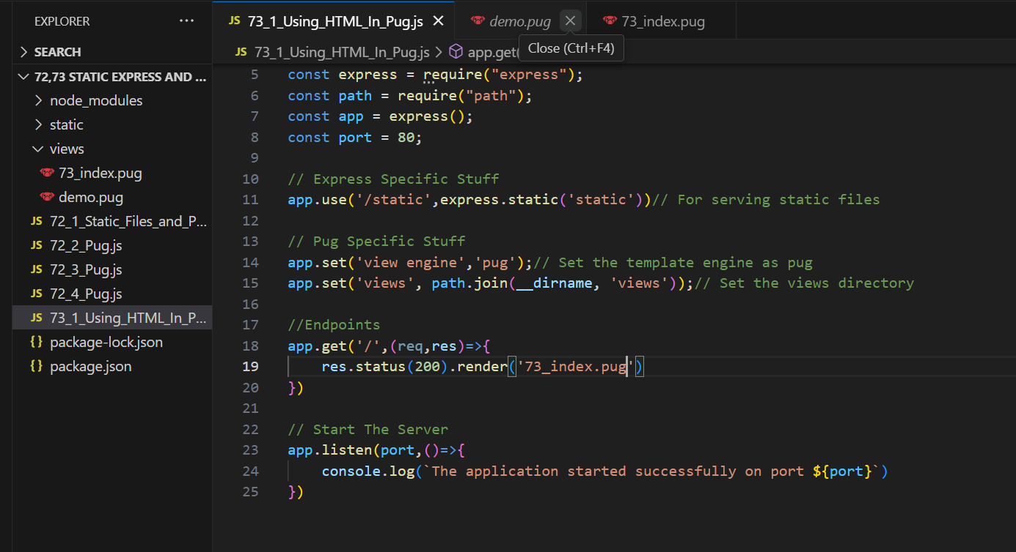
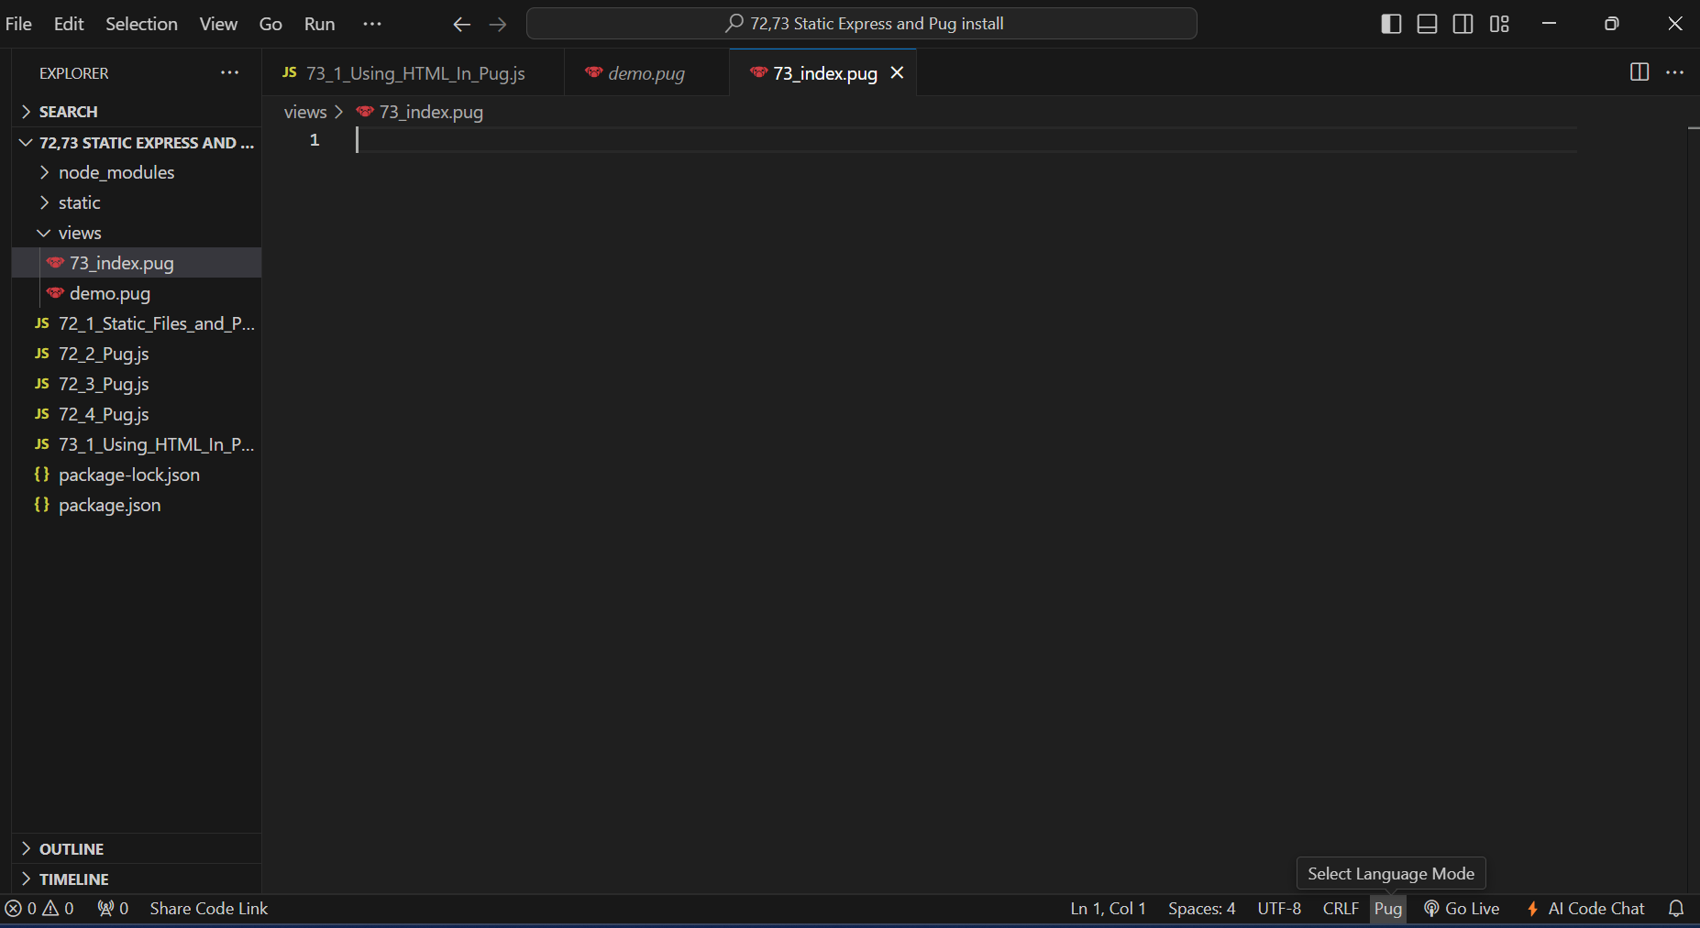
click pug
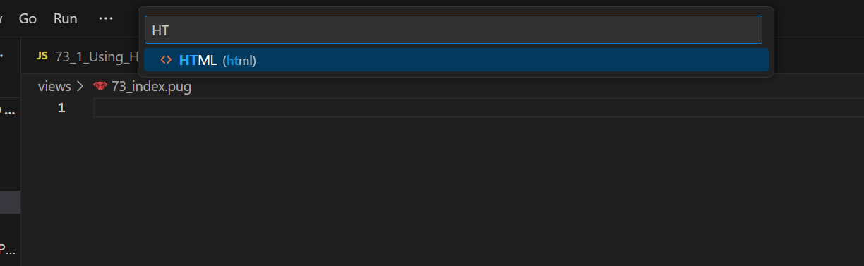
Select Html and convert this pug to html
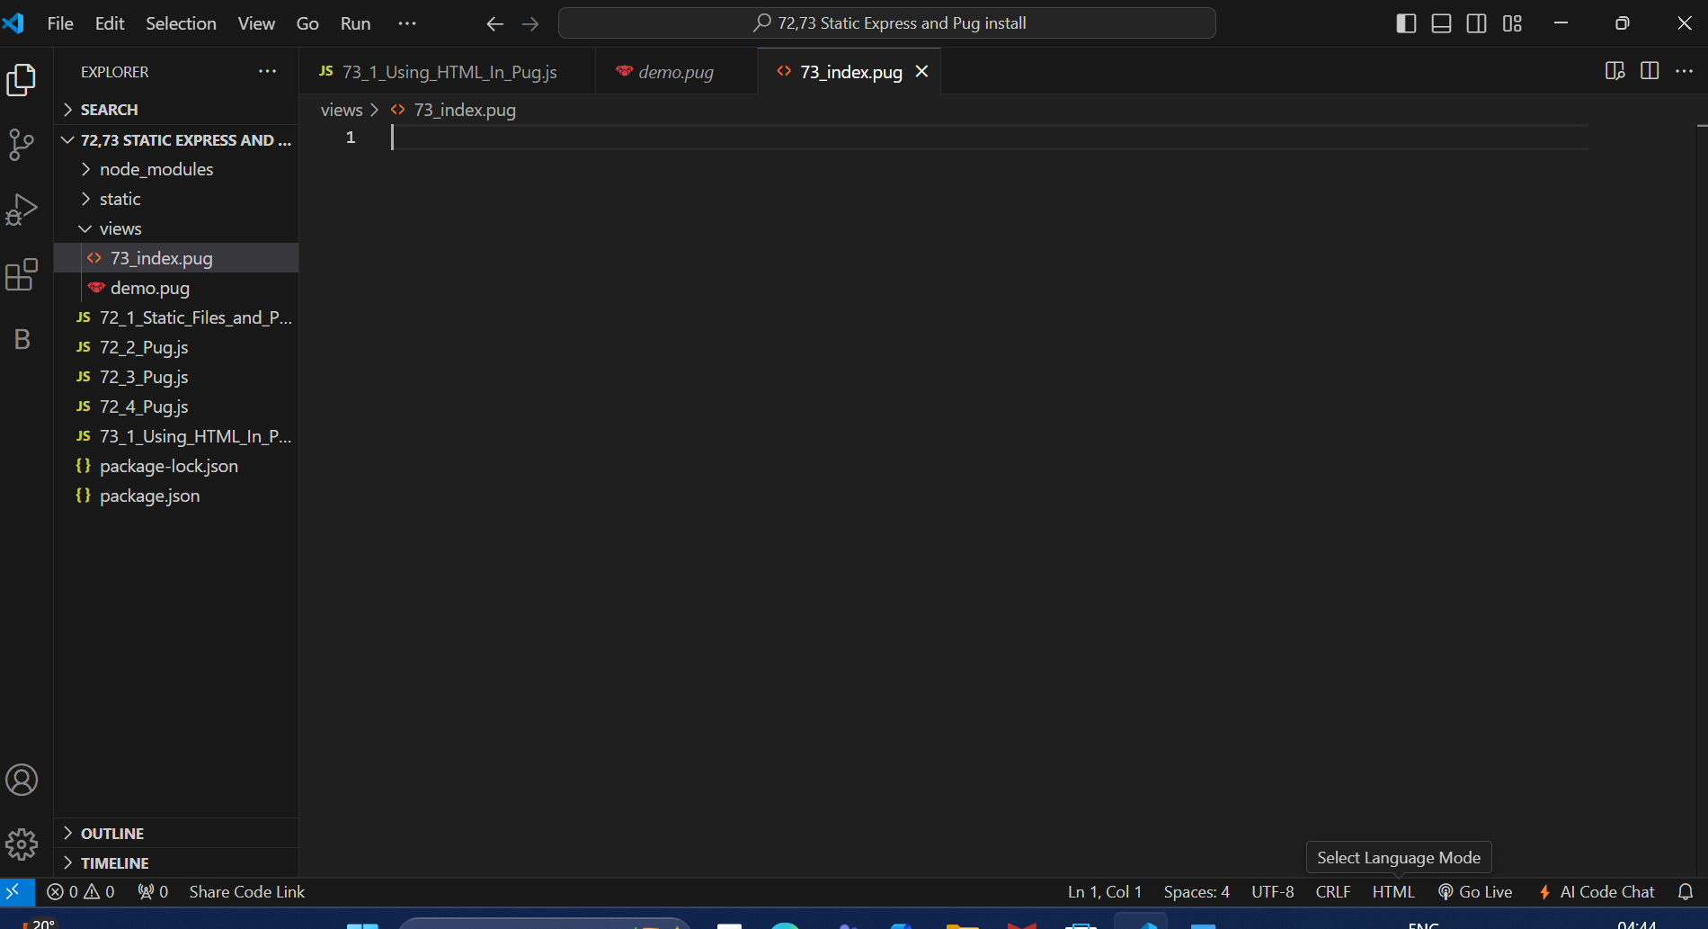
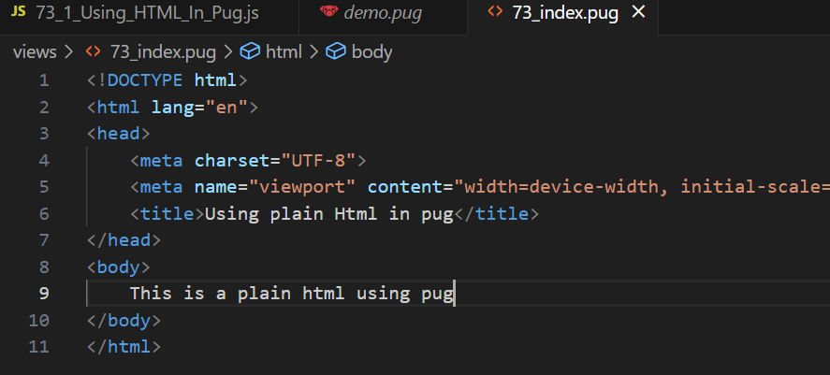
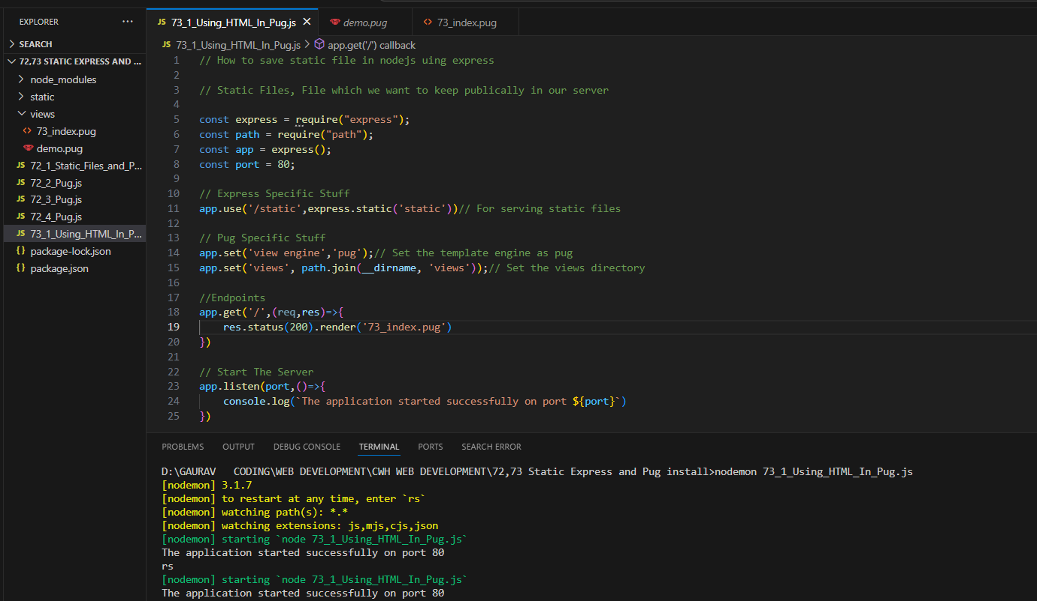
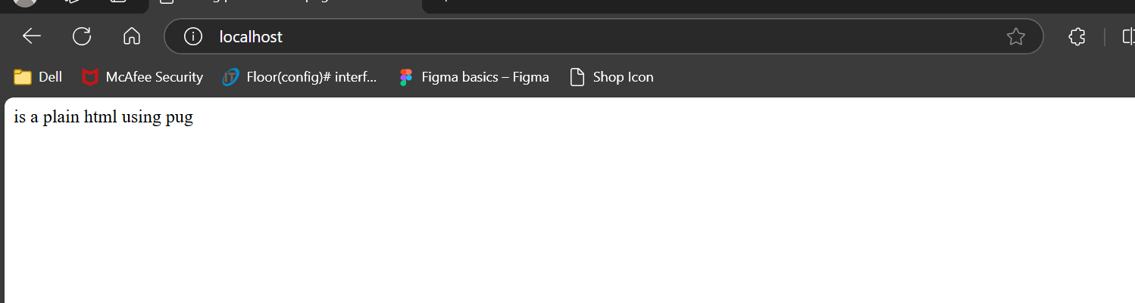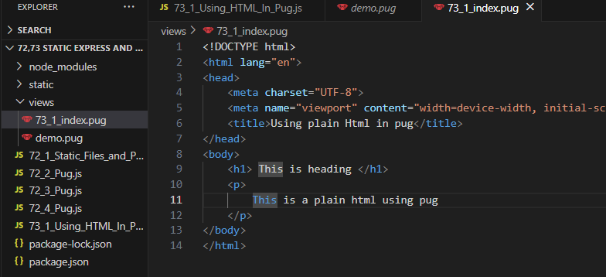
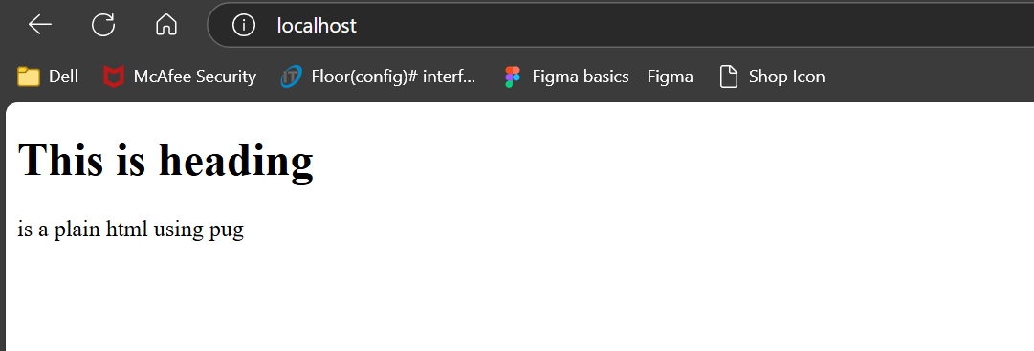
Sending Variable(parameters) directly to pug
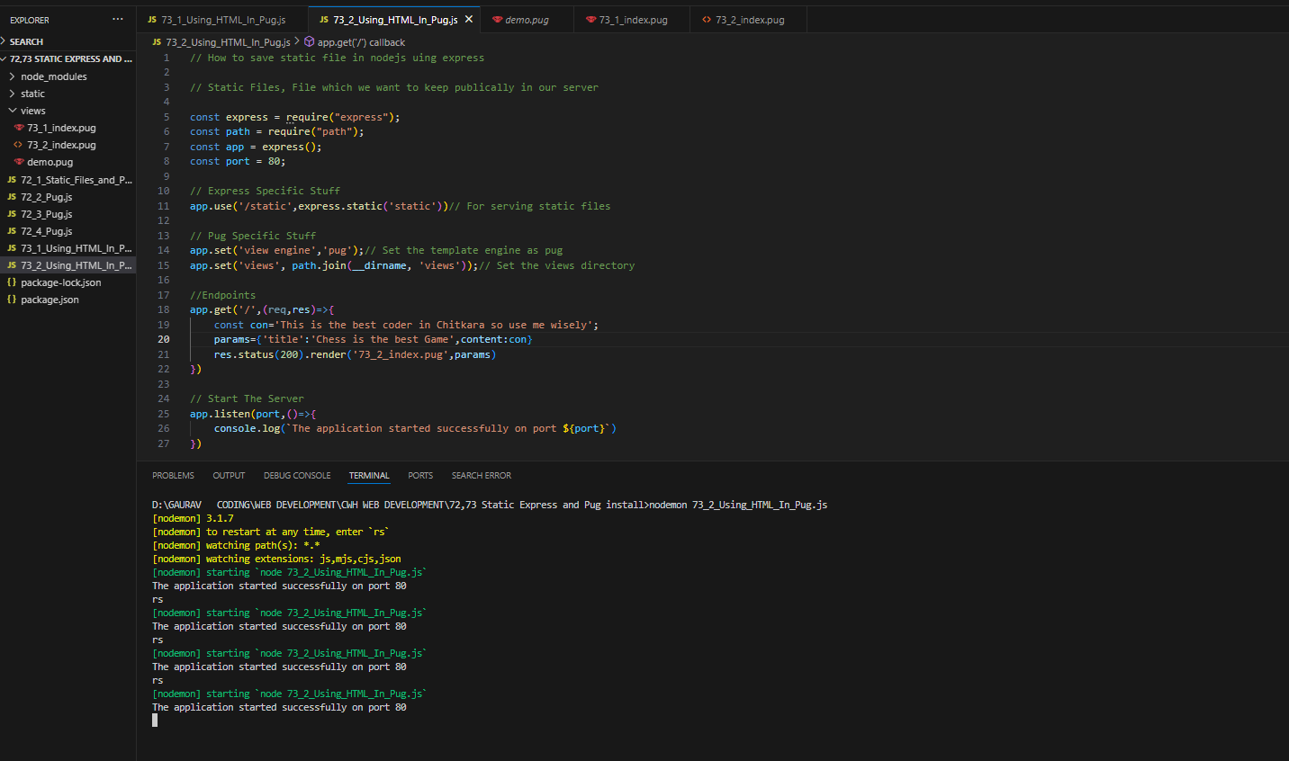 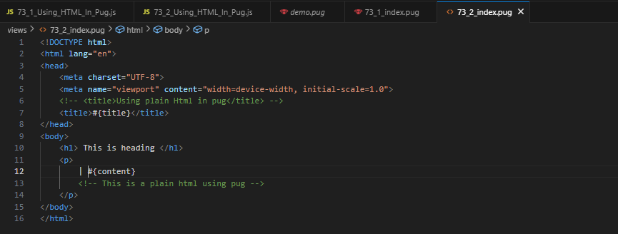
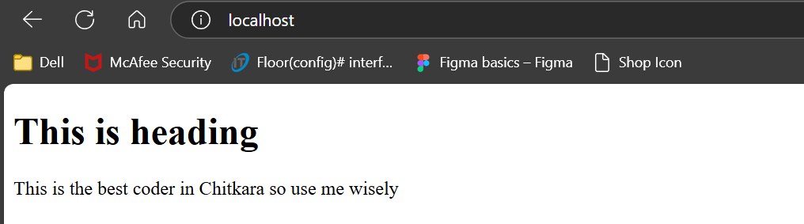

To add CSS to Pug
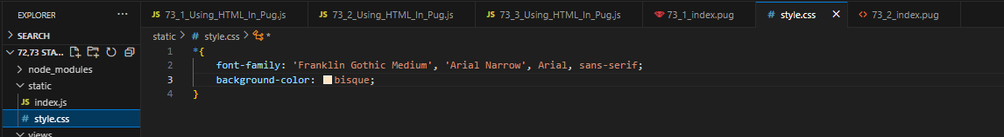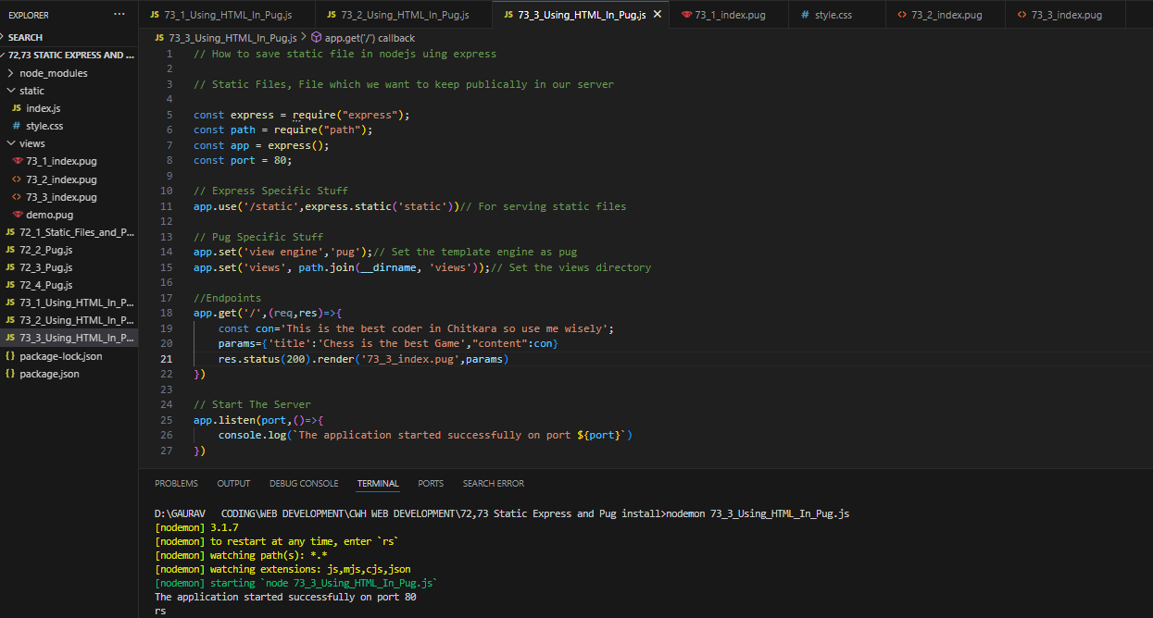
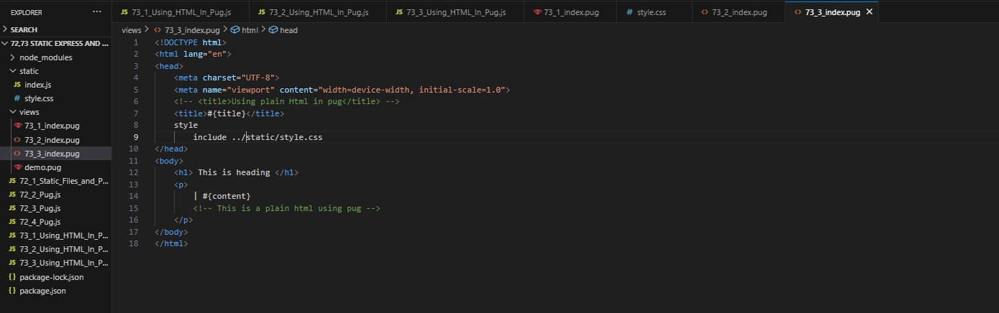
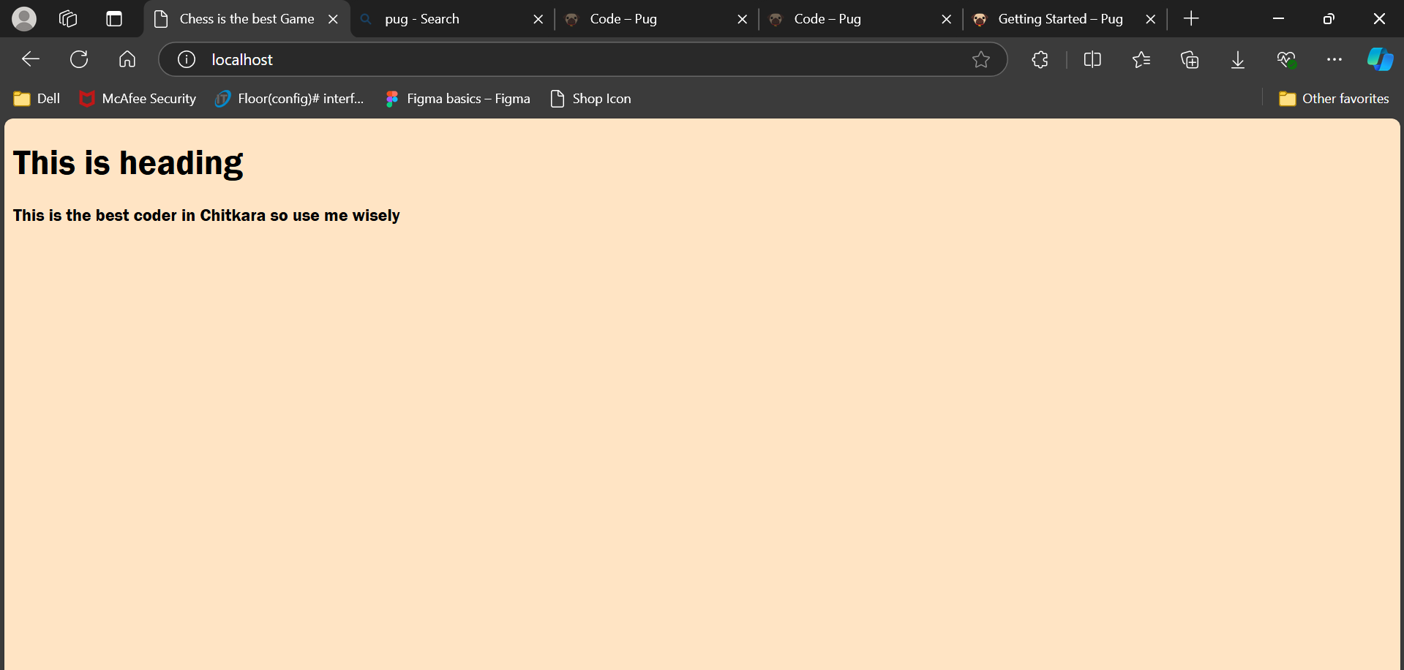
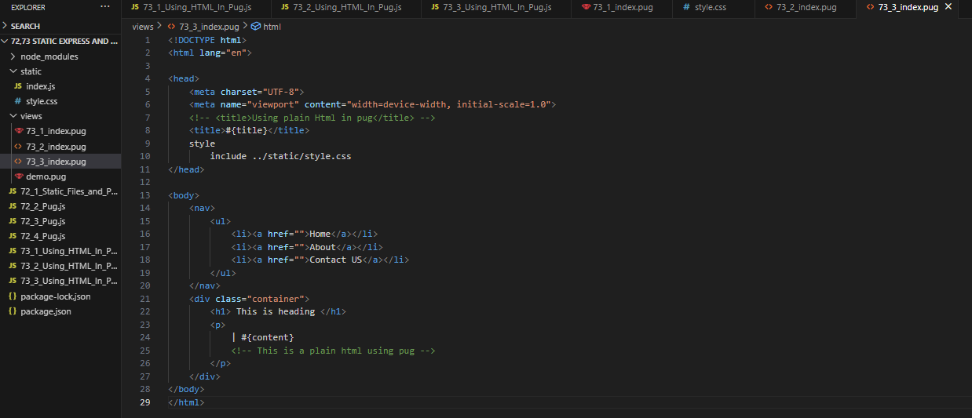
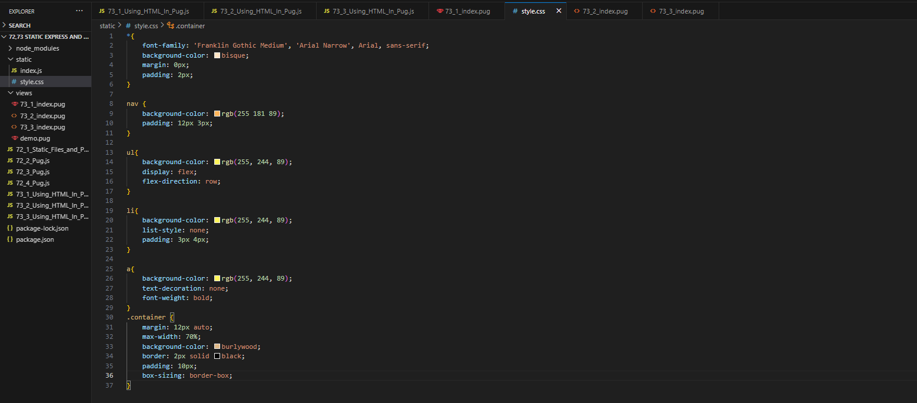
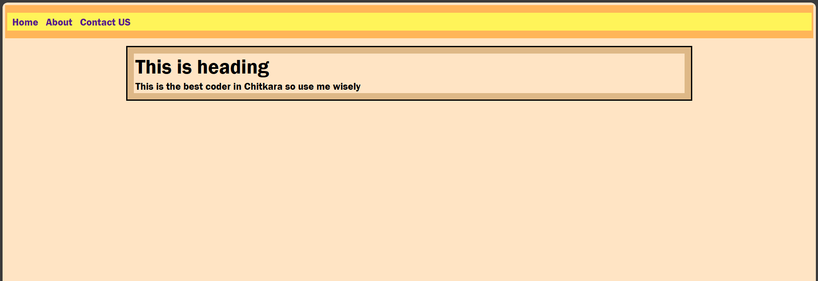
To print form data at terminal/ Console:-
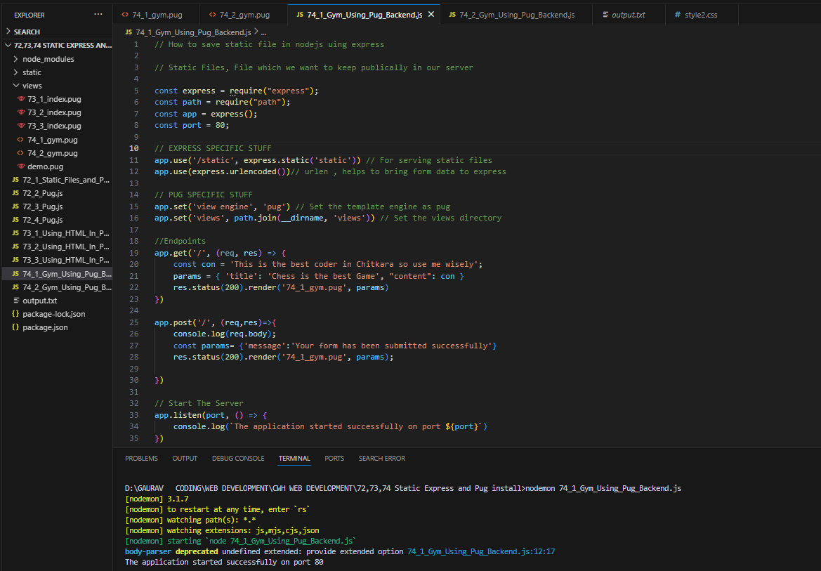
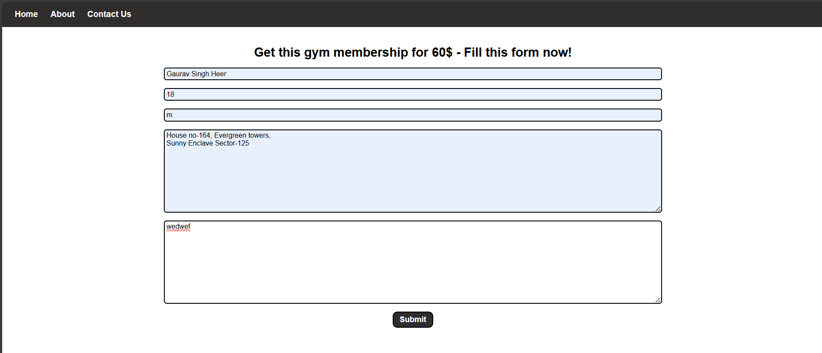
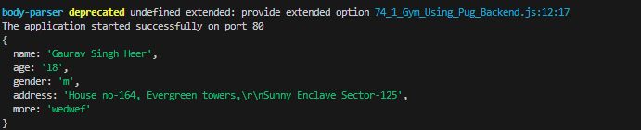
To print form data at output.txt:-
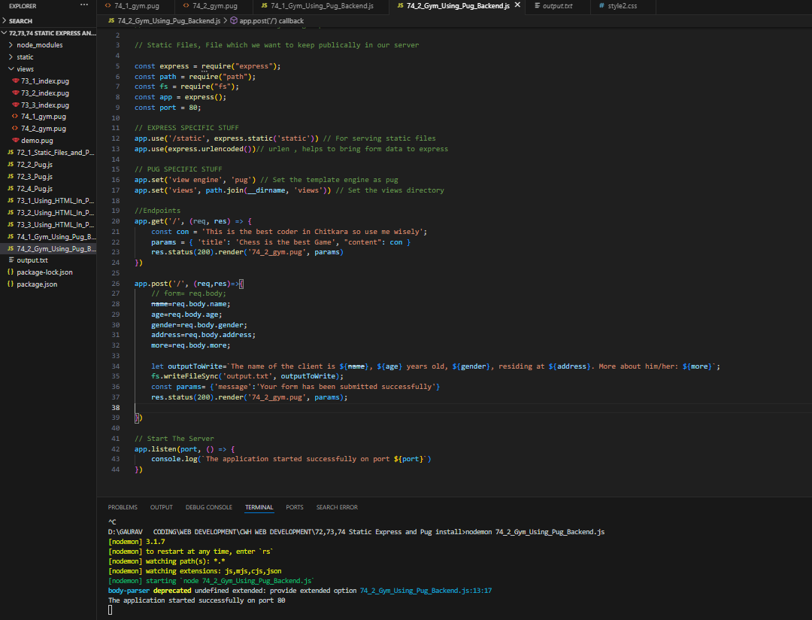
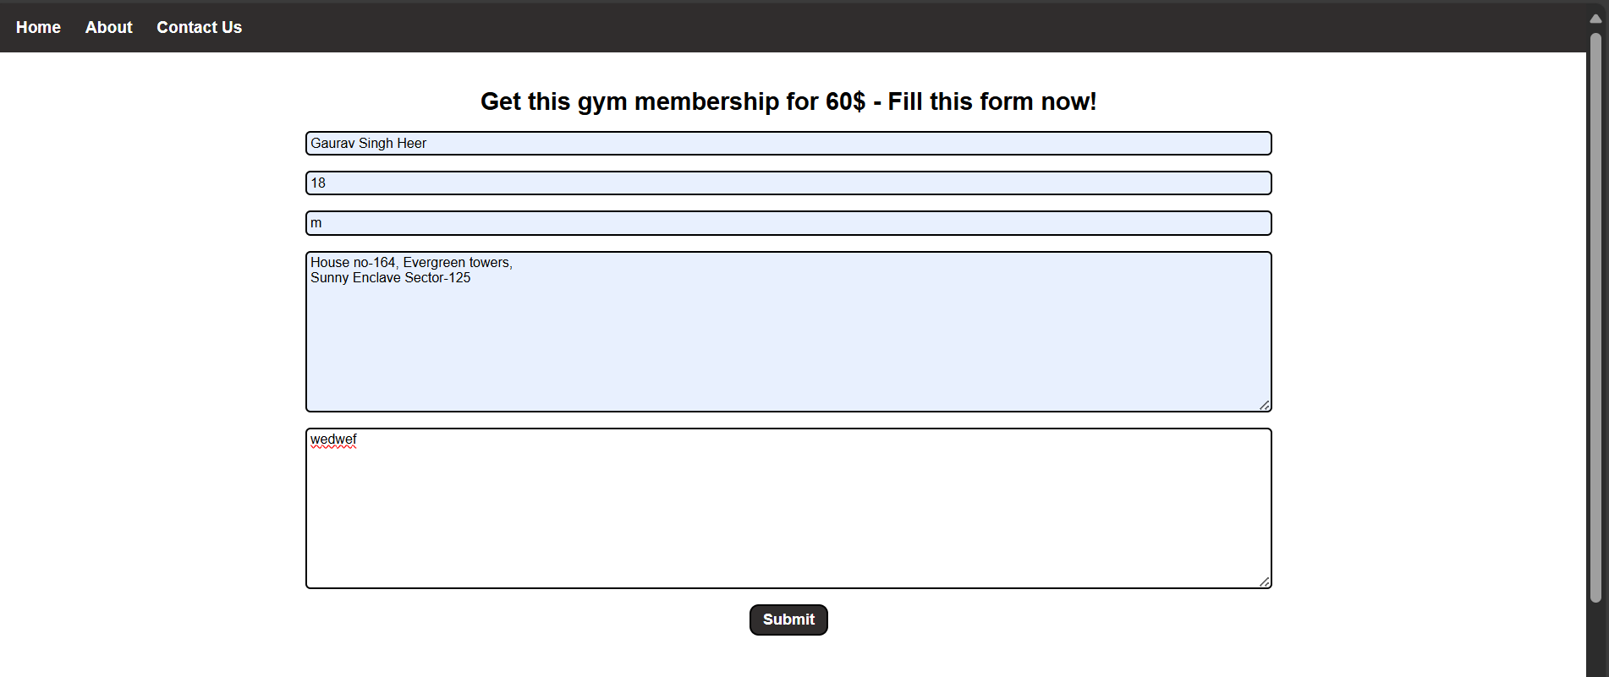
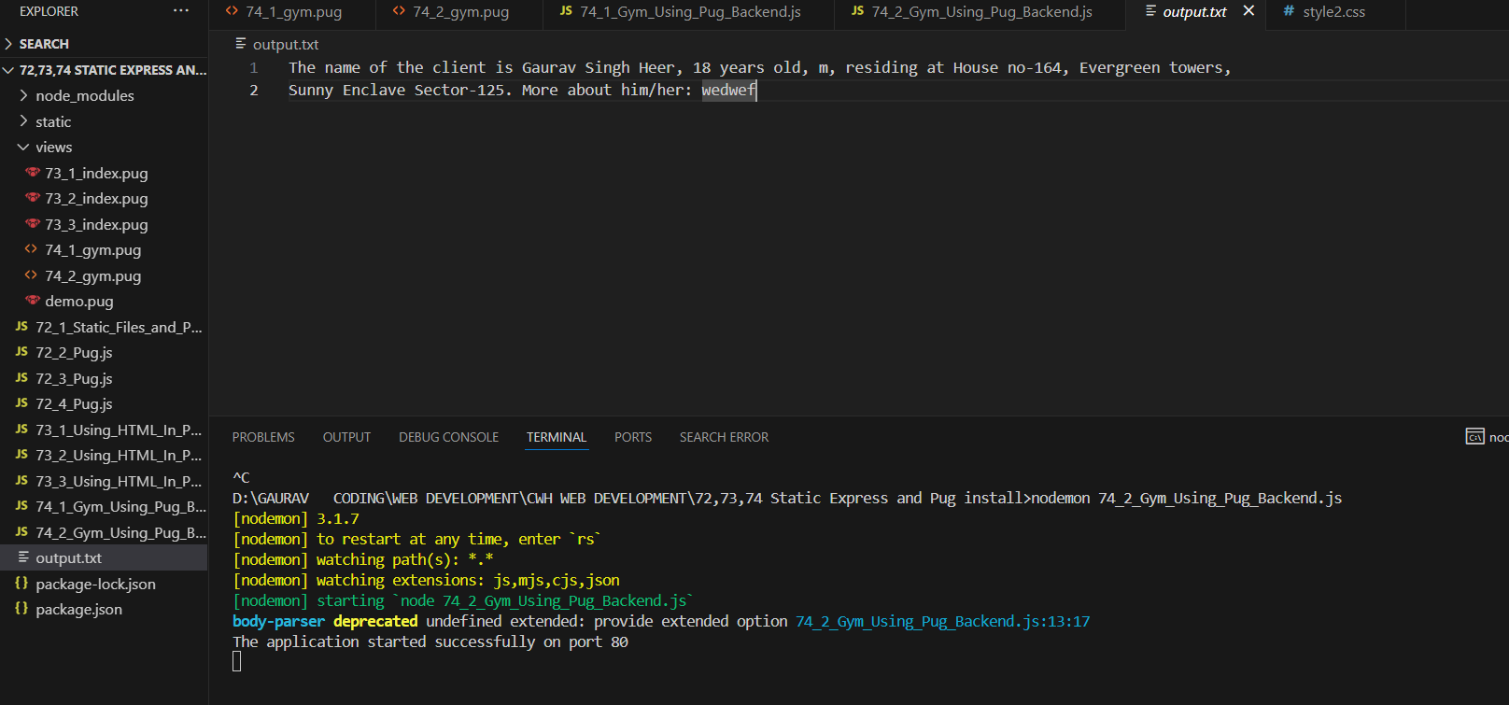
75) Dance Site using PUG
Setup:-
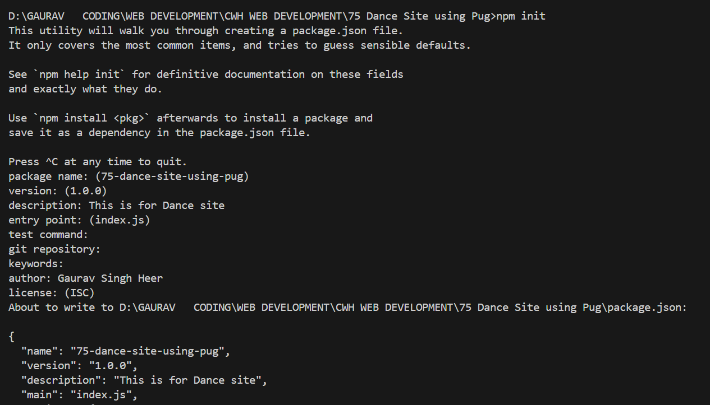
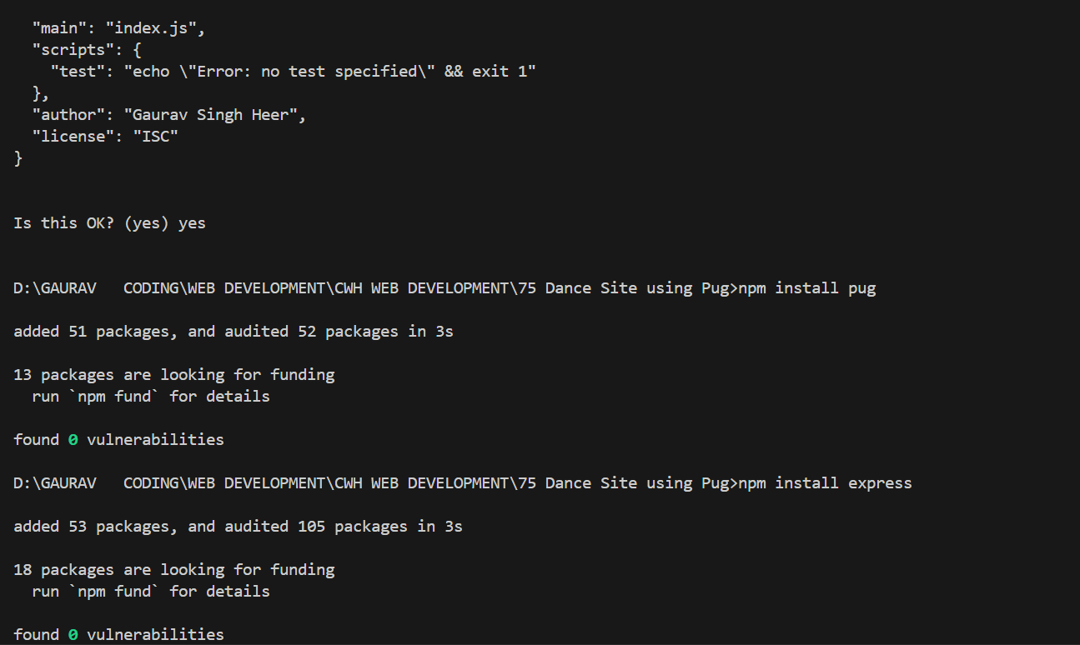
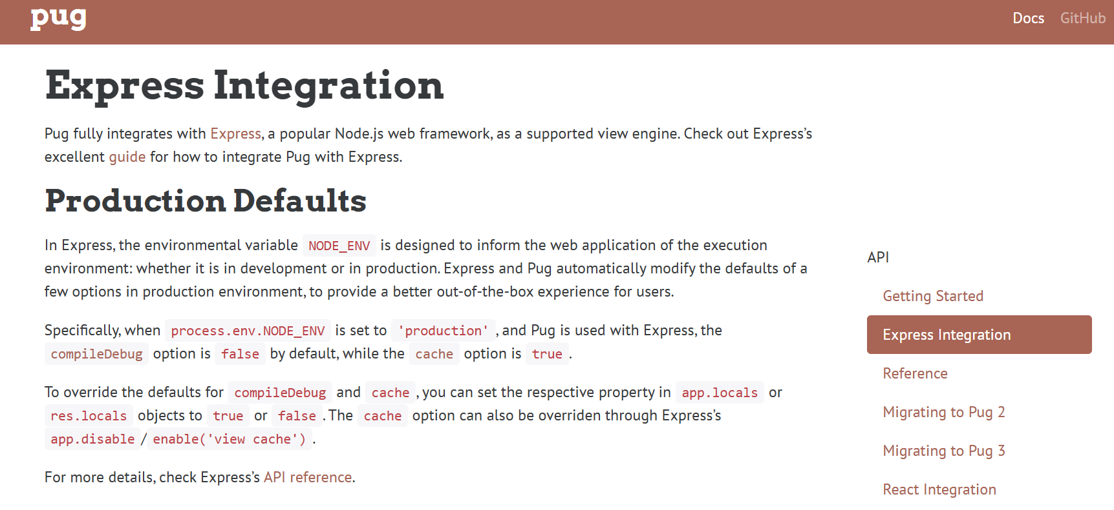
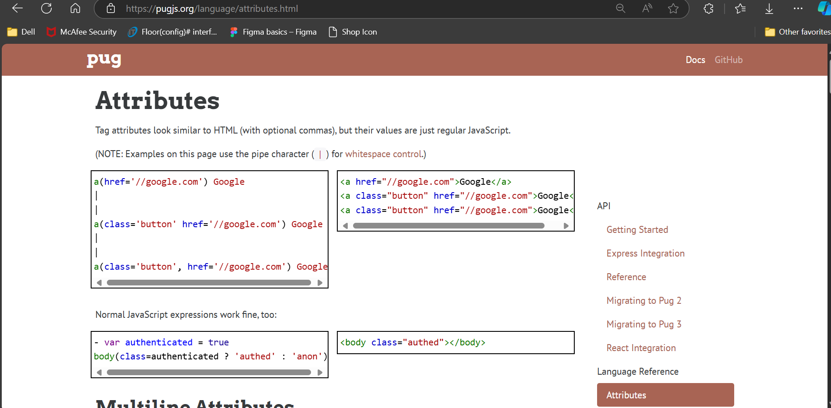
1.
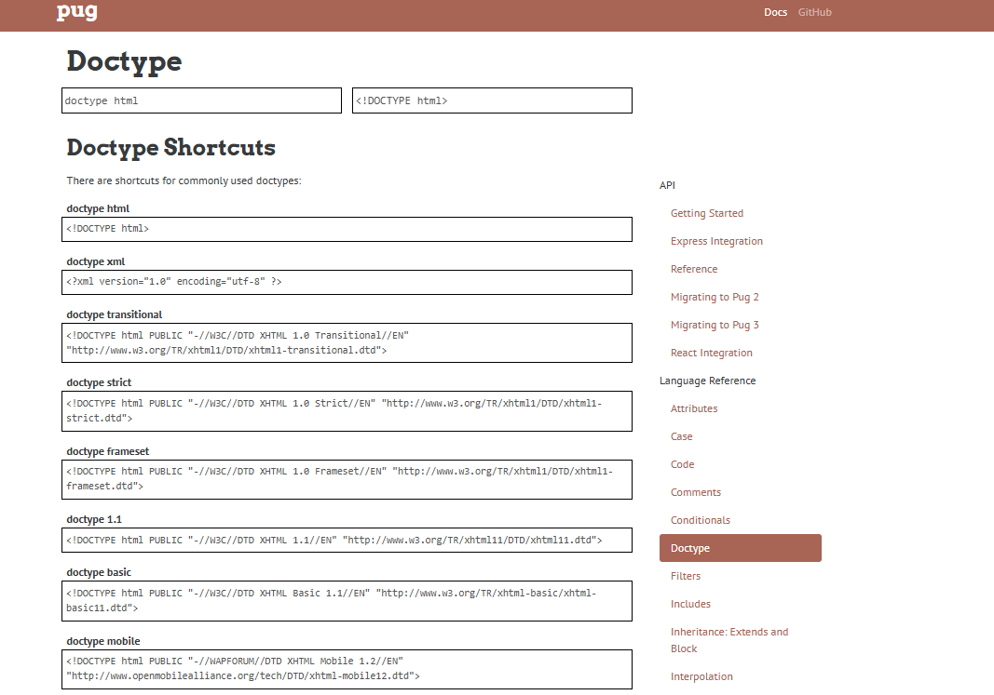
2)
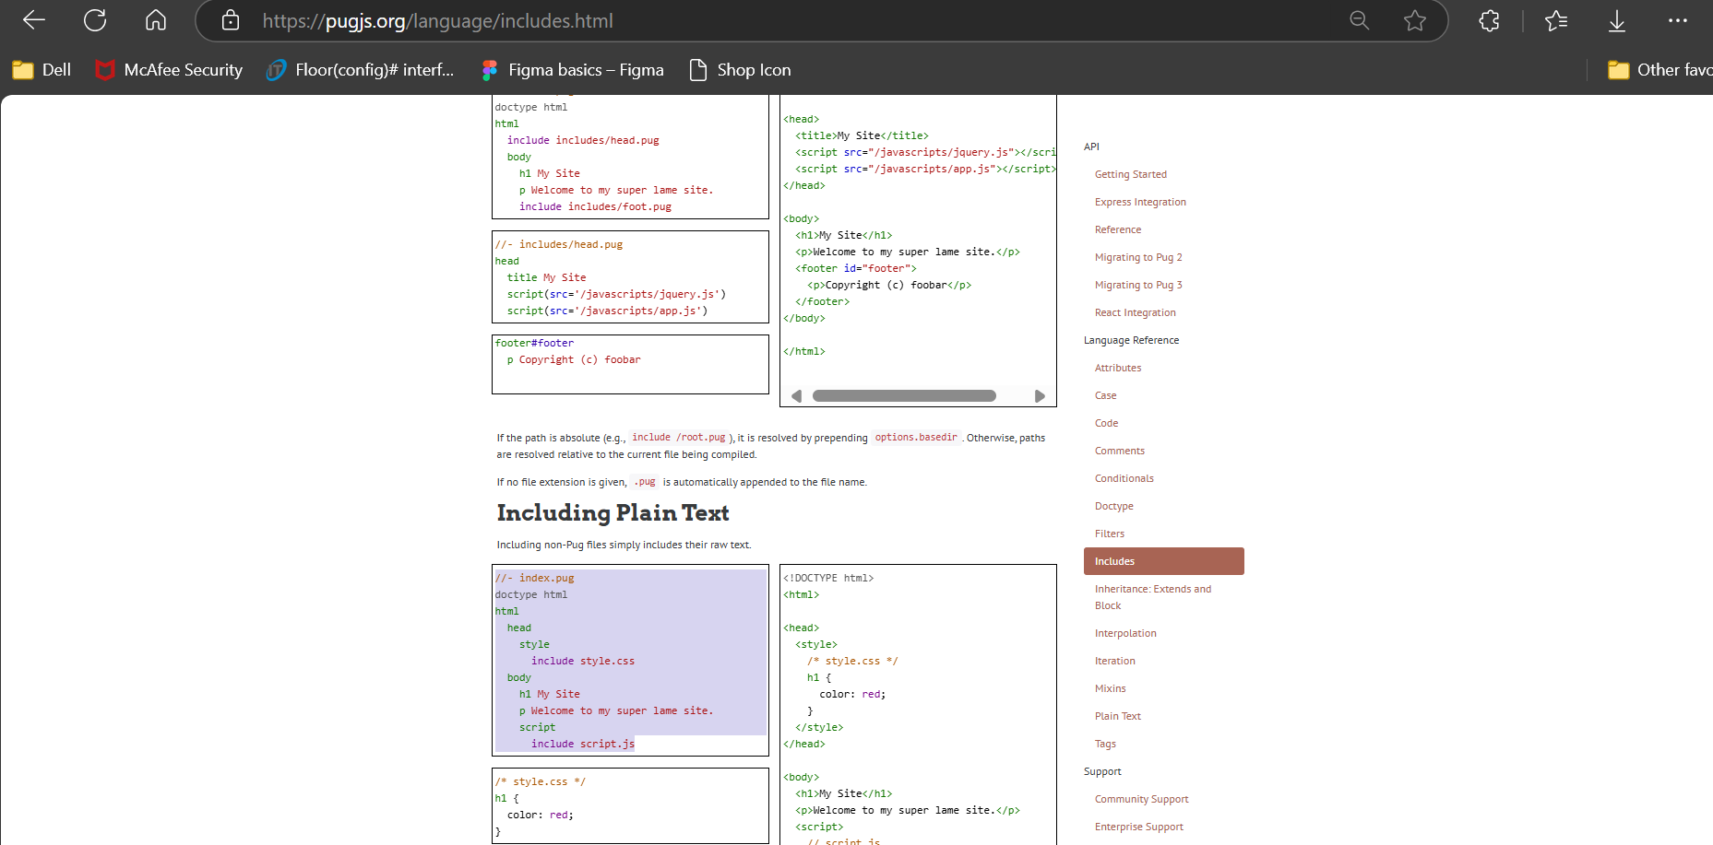
3)
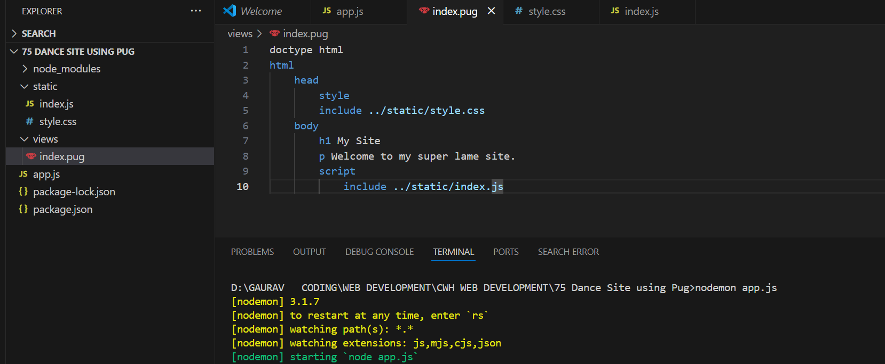
4)
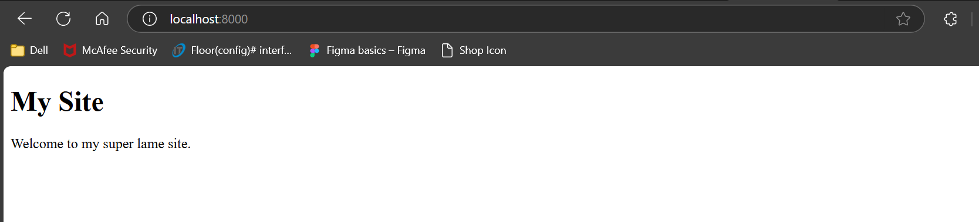

5)
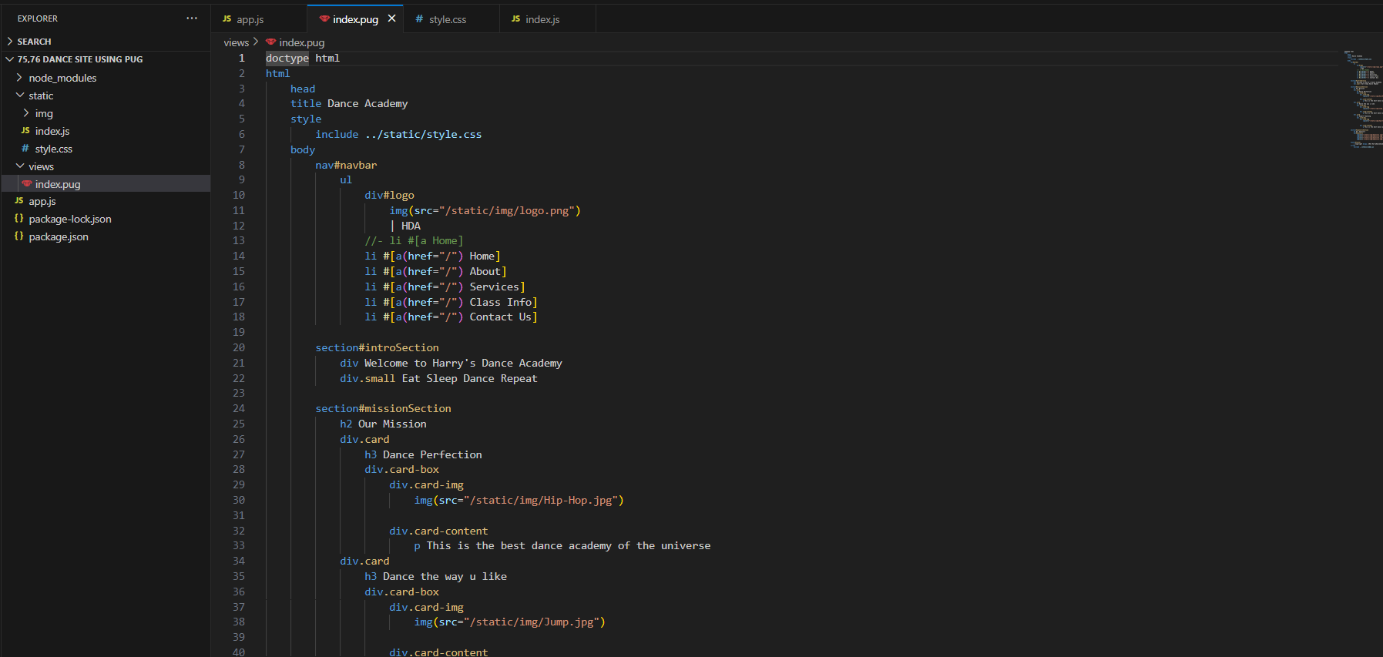

6) (79 vid)
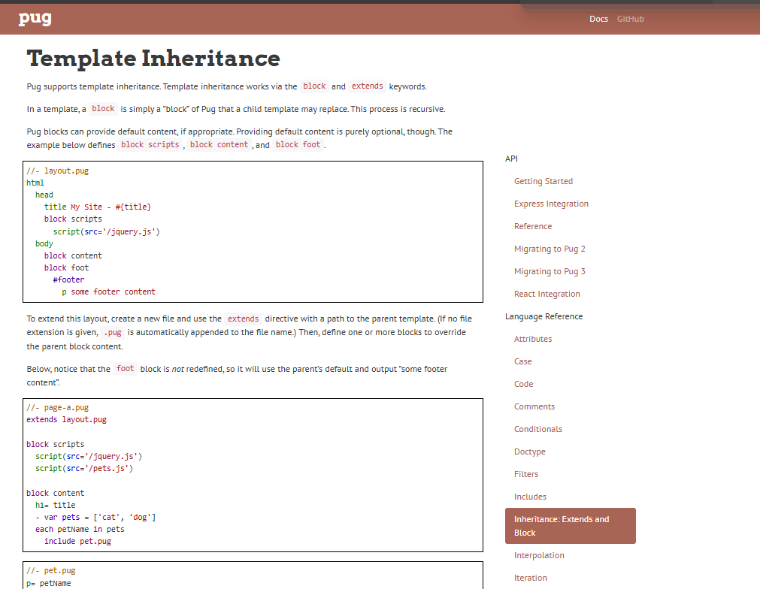

7)

